

Happy Programming

**Final Release Document**

– Hanoi, Jul 2022 –

**Table of Contents**

I. Deliverable Package 3

II. Installation Guides 3

III. User Manual 5

1. Overview 5

2.Actors & Roles 5

1.Sign up 6

4.Mentor Create CV & Slot 6

5.Mentee Create Request 12

a. Luồng Mentee tạo request 12

b. Finishing when completed course 16

6.Mentor Inviting Request 19

a. Inviting Request Management 19

7.Manager 20

b. Manager CV & Slot of Mentor 20

c. Manager Payment 22

8.Admin 24

[a . Admin manage Skill  
-Admin logs in with an account that has been granted admin rights 24](#_heading=h.8ic9p8oa3mhl)

b. Admin manage User 26

c. Admin manage request 29

# I. Deliverable Package

| **No.** | **File** | **Notes** |
| --- | --- | --- |
| 1 | SE1878_JS(IT)_G3_HP_DB_Final.sql | Database, including both table structures and table data |
| 2 | SE1878_JS(IT)_G3_RDS Document.docx | Final RDS (Requirement & Design Specification) Document |
| 3 | SE1878_JS(IT)_G3_Product Backlog.xlsx | Final status for the application functions, which include:  - Function name, feature, roles, function description (changes compared to the original requirements are highlighted)  - In Charge, Planned iteration & Actual iteration  - Final status & note on the update you made  - The links to the SRS & SDS are tracked |
| 5 | SE1878_JS(IT)_G3_HP_Project Tracking.xlsx | Product backlog |
| 6 | SE1878_JS(IT)_G3_HP_SourceCode_final.zip | Source code project |

Other related deliverables:

* Tagged source codes: https://gitlab.com/summer20241/se1875-sap/se1878-js-it/group03.git
* Demonstration video: https://youtu.be/UYLmZoKupmQ

# II. Installation Guides

**1. Installation of NetBeans 17**

1. Go to [Downloading Apache NetBeans 17](https://netbeans.apache.org/front/main/download/nb17/)for downloading

**2. Install Java JDK 17**

1. Download JDK 17:

* Go to the Oracle JDK download page.
* Download the appropriate installer for your operating system.

2. Install JDK 17:

* Run the installer.
* Follow the installation instructions provided by the installer.
* Set the JAVA_HOME environment variable to point to the JDK installation

directory.

**3. Install and Configure SSMS**

1.Download and install SSMS

* Go to the official Microsoft [SSMS Download Page](https://learn.microsoft.com/sql/ssms/download-sql-server-management-studio-ssms) for SSMS:
* Download the latest version of SSMS by clicking on the download link
* Run the downloaded installer (SSMS-Setup-<version>.exe) as an administrator.The installation process will take a few minutes. Once complete, click Close.

2.Download and install the SQL Server

* Go to the official Microsoft [SQL Server](https://www.microsoft.com/en-us/sql-server/sql-server-2019) to download SQL Server
* Follow the installation wizard to set up SQL Server.

2. Install Tomcat 10

1. Download Tomcat 10

● Go to the Apache Tomcat 10 download page.

● Download the ZIP file for your operating system.

2. Install Tomcat 10

● Extract the downloaded ZIP file to a directory of your choice

3. Configure Tomcat 10 in NetBeans

1. Open NetBeans.

2. Go to Tools > Servers in the top menu.

3. Click Add Server.

4. Select Apache Tomcat from the list, then click Next.

5. Browse to the directory where you extracted Tomcat (e.g., C:\Tomcat

or /usr/local/tomcat).

6. Complete the configuration by setting any additional parameters (e.g.,

admin username and password if required).

4. Set Up JDBC Driver for MySQL

1. Download the MySQL JDBC Driver

● Go to the MySQL Connector/J (JDBC Driver) download page.

● Download the latest version of the MySQL JDBC driver.

2. Add the JDBC Driver to NetBeans

1. Open NetBeans.

2. Go to Tools > Libraries.

3. Click New Library.

4. Name the library (e.g., MySQL JDBC Driver).

5. Click Add JAR/Folder and browse to select the .jar file(s) you

downloaded for the MySQL JDBC driver.

6. Click OK to add the driver.

# III. User Manual

## 1. Overview

**The Happy Programming System is a new software platform designed to facilitate online connections between mentors, mentees, and other actors involved in programming education. This system replaces the current manual processes of coordinating mentorship and learning activities.**

**The Happy Programming System is envisioned to evolve over several releases, eventually integrating with online learning platforms, programming resources, and potentially third-party educational tools. The goal is to streamline the support and learning experience for mentees, allowing them to easily access mentorship and resources to enhance their programming skills.**

## 2.Actors & Roles

The platform has four primary roles, each with distinct functionalities:

**1. Admin:**

○ Manages adding and categorising skills offered by mentors.

○ Oversees mentor applications and account management.

○ Ensures platform security, compliance, and smooth operation.

**2. Manager:**

○ Handles requests from mentees and tracks mentor profiles.

○ Approves or rejects CV from Mentor

○ Manages mentor verification.

**3. Mentor:**

○ Provides coding mentorship, technical guidance, and project advice.

○ Sets up a profile with expertise areas, availability, and rates.

○ Manages sessions and interactions with mentees.

○ Approves or rejects Mentee request.

**4. Mentee:**

○ Hires mentors for personalised guidance on specific coding skills.

○ Browses mentor profiles, submits requests, and attends sessions.

○ Can give feedback on the mentorship received

**5.Guest:**

○ Can browse mentor profiles to understand their expertise, availability, and rates.

○ To book sessions, guests need to sign up as a mentee.

○ Cannot submit session requests, hire mentors, or give feedback until registered

**6.VNPAY:**

○ Enables secure, integrated payment transactions for mentees to pay mentors

○ Mentees can view past transactions, including dates, amounts, and mentor details.

○ Provides support for refunds or disputes, if needed.

## 3.Sign up

## 

## 4.Mentor Create CV & Slot

This workflow assists mentors in creating their professional CVs and setting up a teaching schedule to begin sessions with mentees.

#### Step 1: Login Mentor account, click CV in navbar

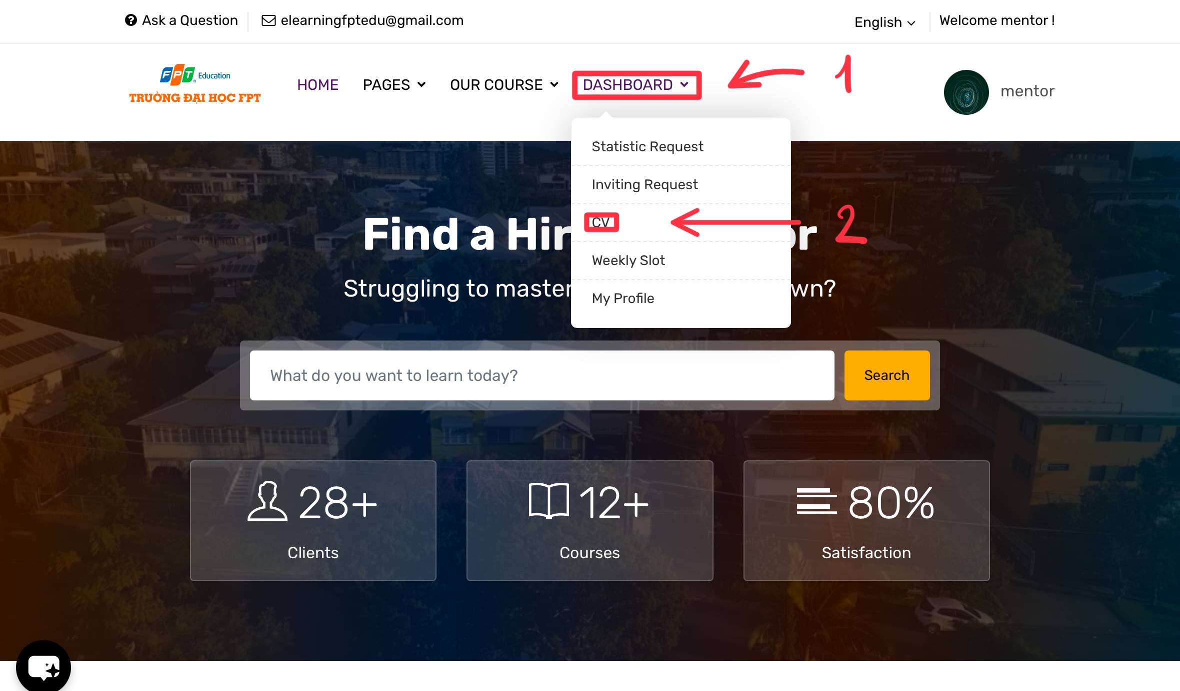

#### Step 2: Click Create CV+

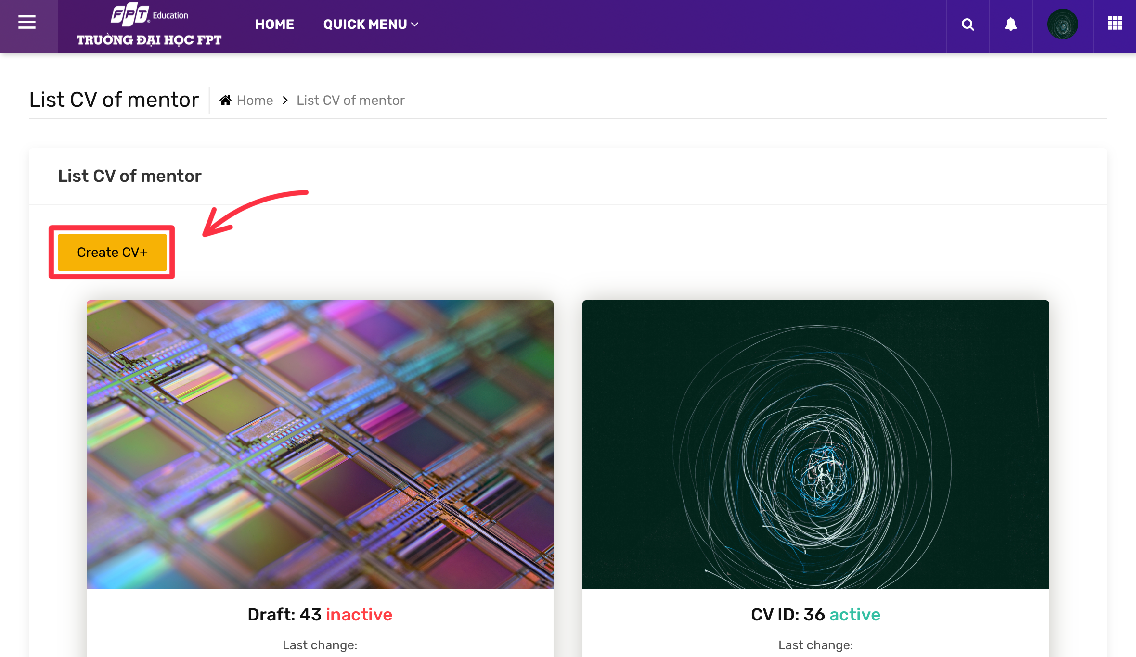

#### Step 3: Input information and Save change

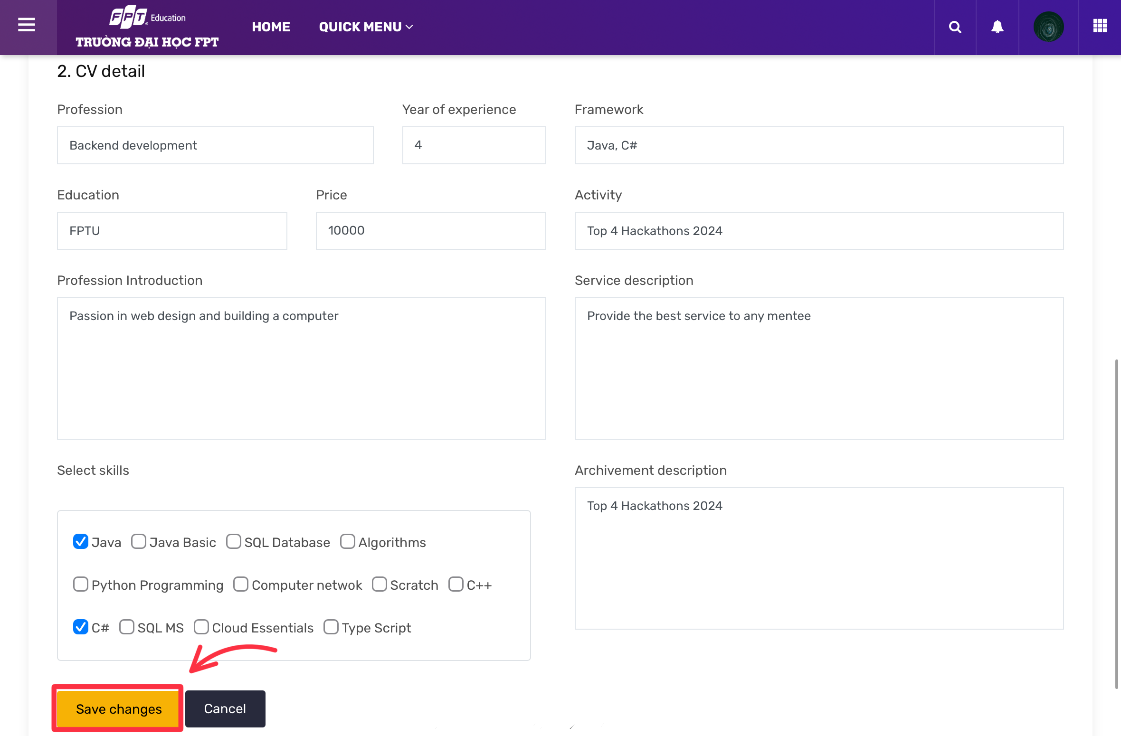

#### Step 4: System display success, you need to wait for the manager approve cv to continue!

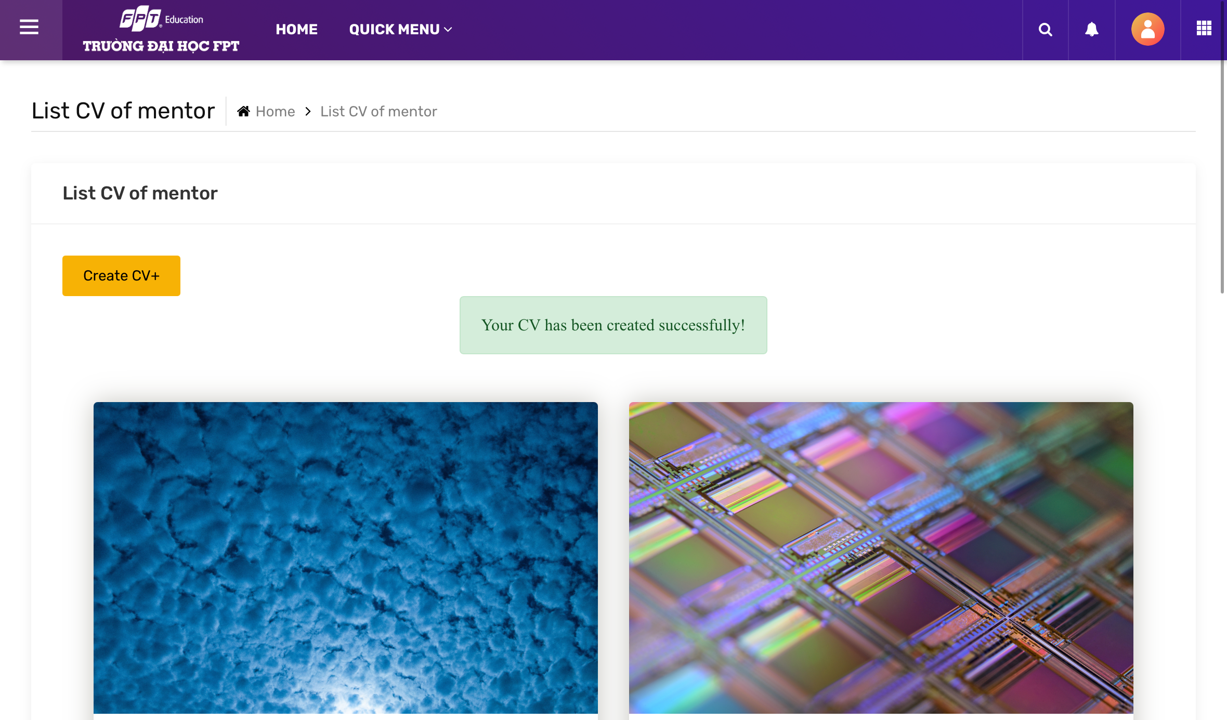

#### Step 5: After manager approve your CV, you can create new slot

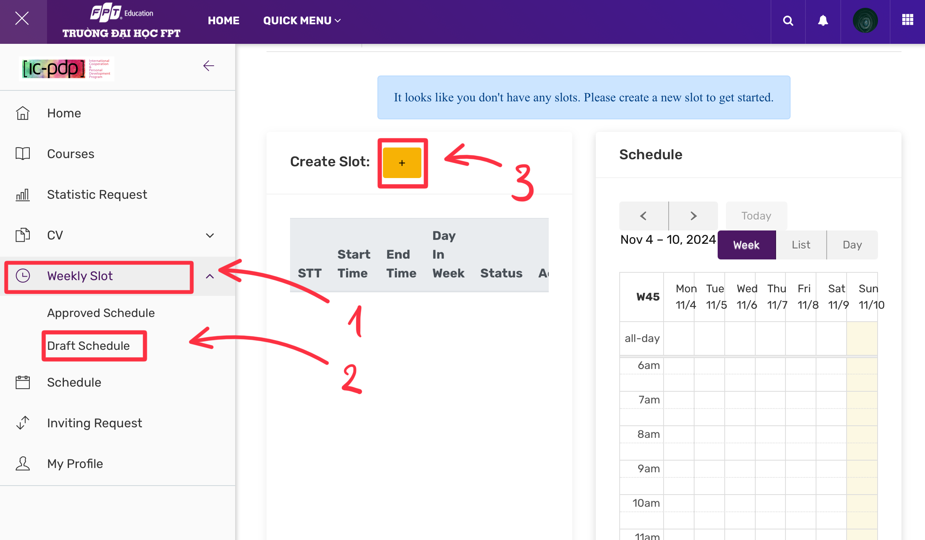

#### Step 6: Choose slot you want to teach then click save change

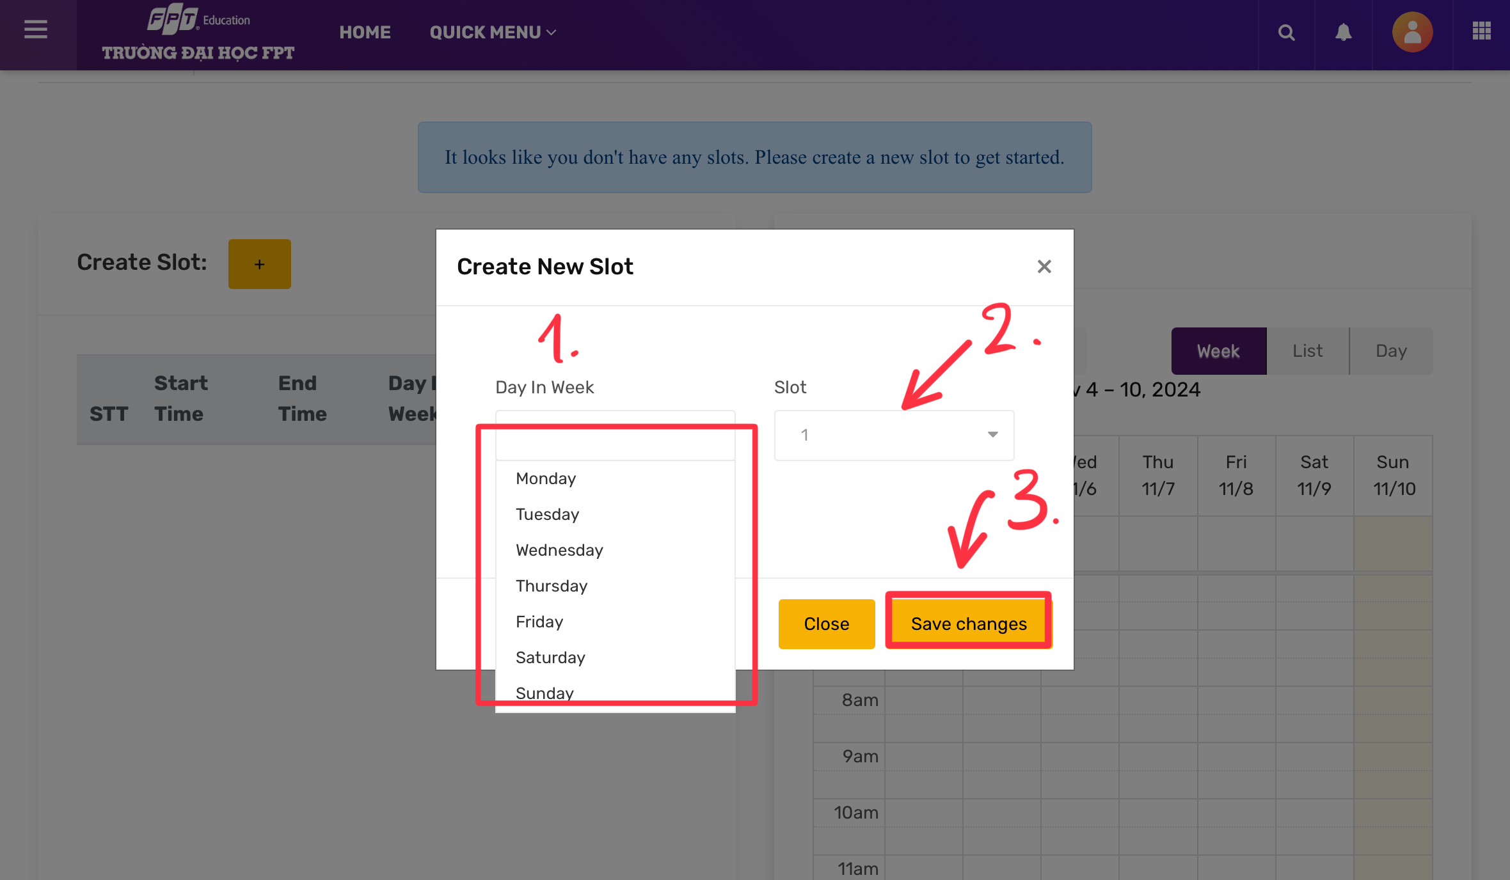

#### Step 7: System display successfully, you need to wait for manager approve your schedule

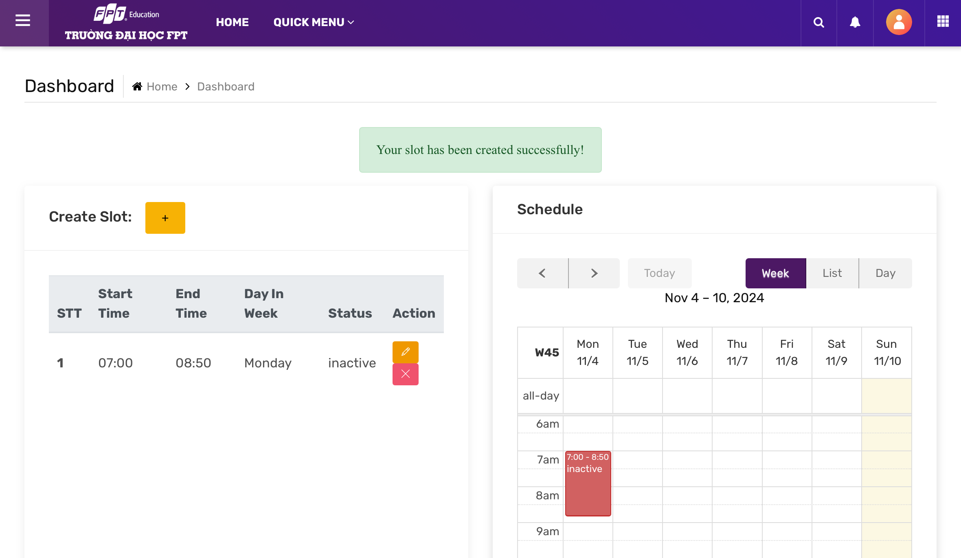

## 5.Mentee Create Request

### a. Luồng Mentee tạo request

**Step 1:** Mentee login to their account

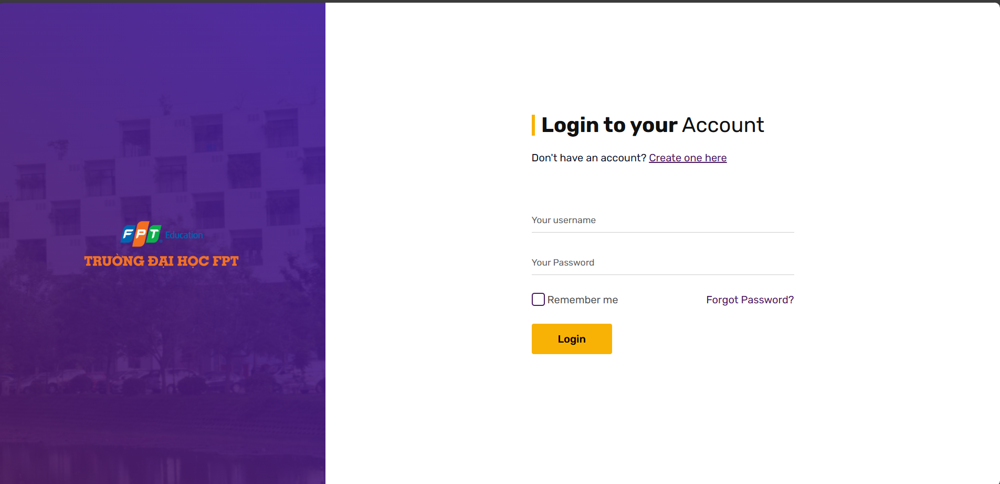

**Step 2:** Mentee access to course page to view all skill of Happy Programming and select skill they want to learn

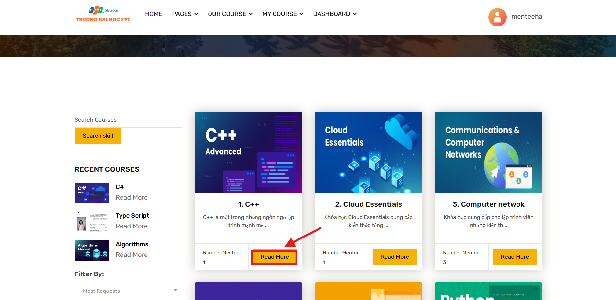

**Step 3:** Mentee select mentor they want to learn and click “Rent mentor” to create request to that mentor

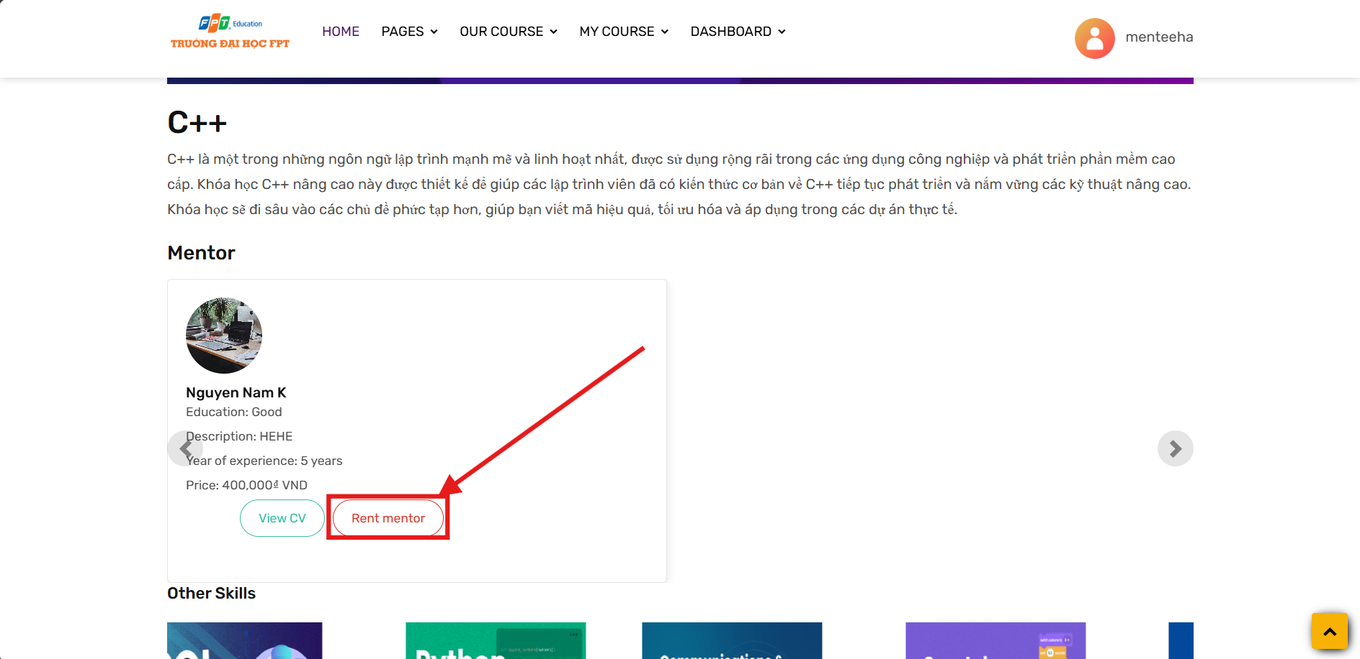

**Step 4:** Fill all required fields and click on “Create Request” to complete the process

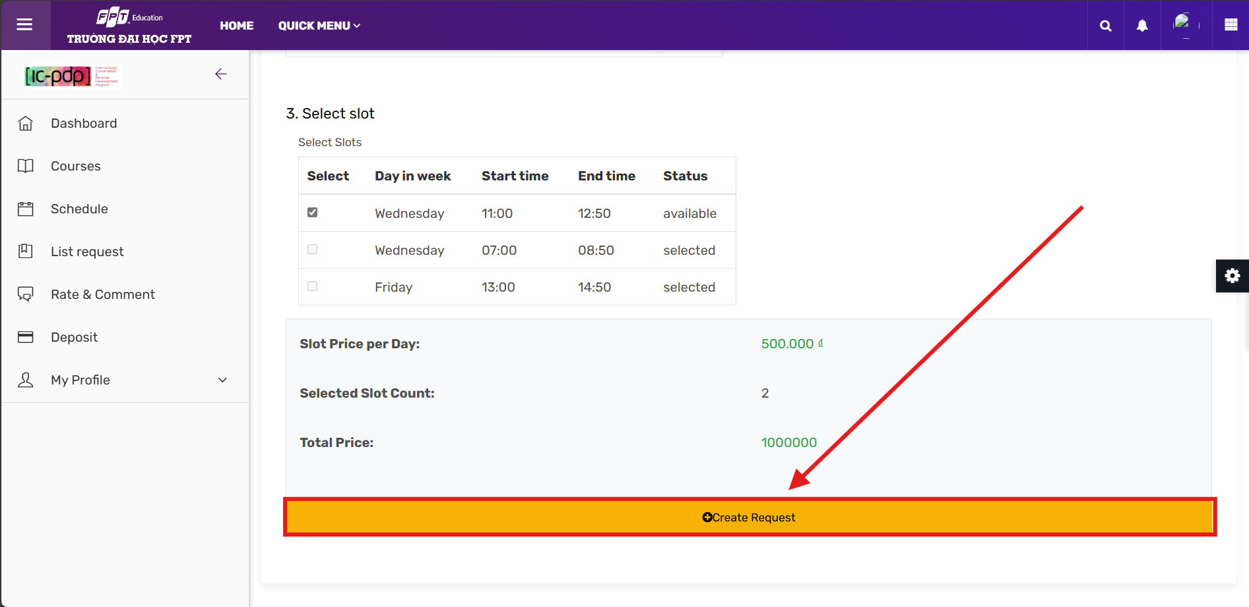

**Step 4.1:** If your amount is not enough to make a request, you need to charge money to continue creating request

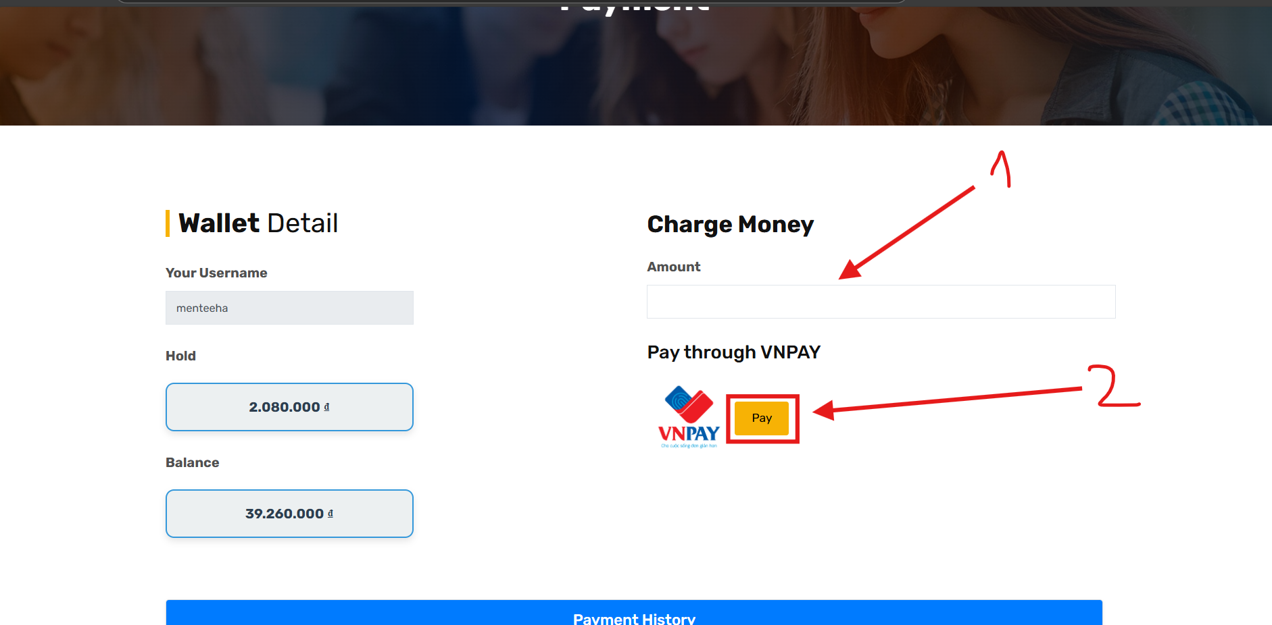

**Step 5 :**Check status of your request at list request by clicking on “List request” on left side bar

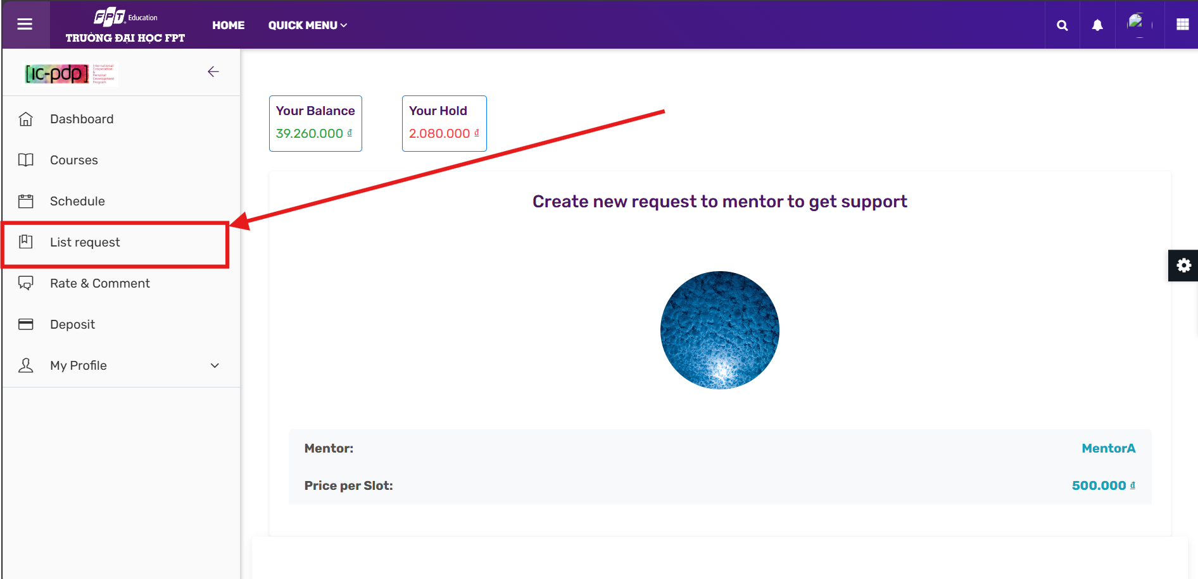

**Step 6 :**You can update, view or cancel request if mentor not accept request

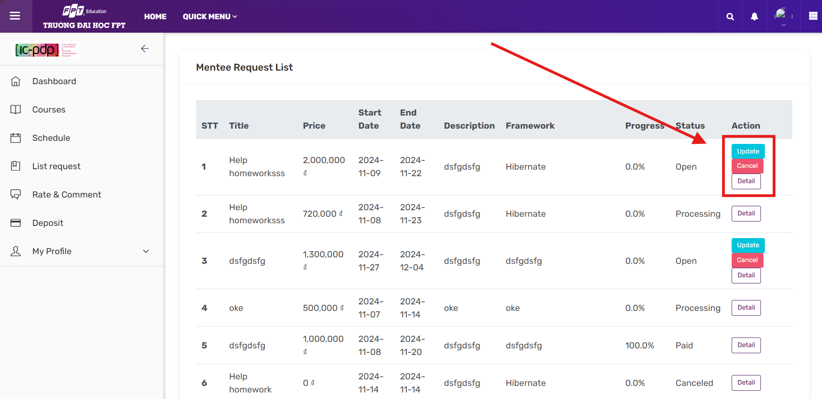

**Step 7:** Let finish the course to reach 100% of progress to complete by the Complete button.

*1. Mentee can update their request and monitor their progress*

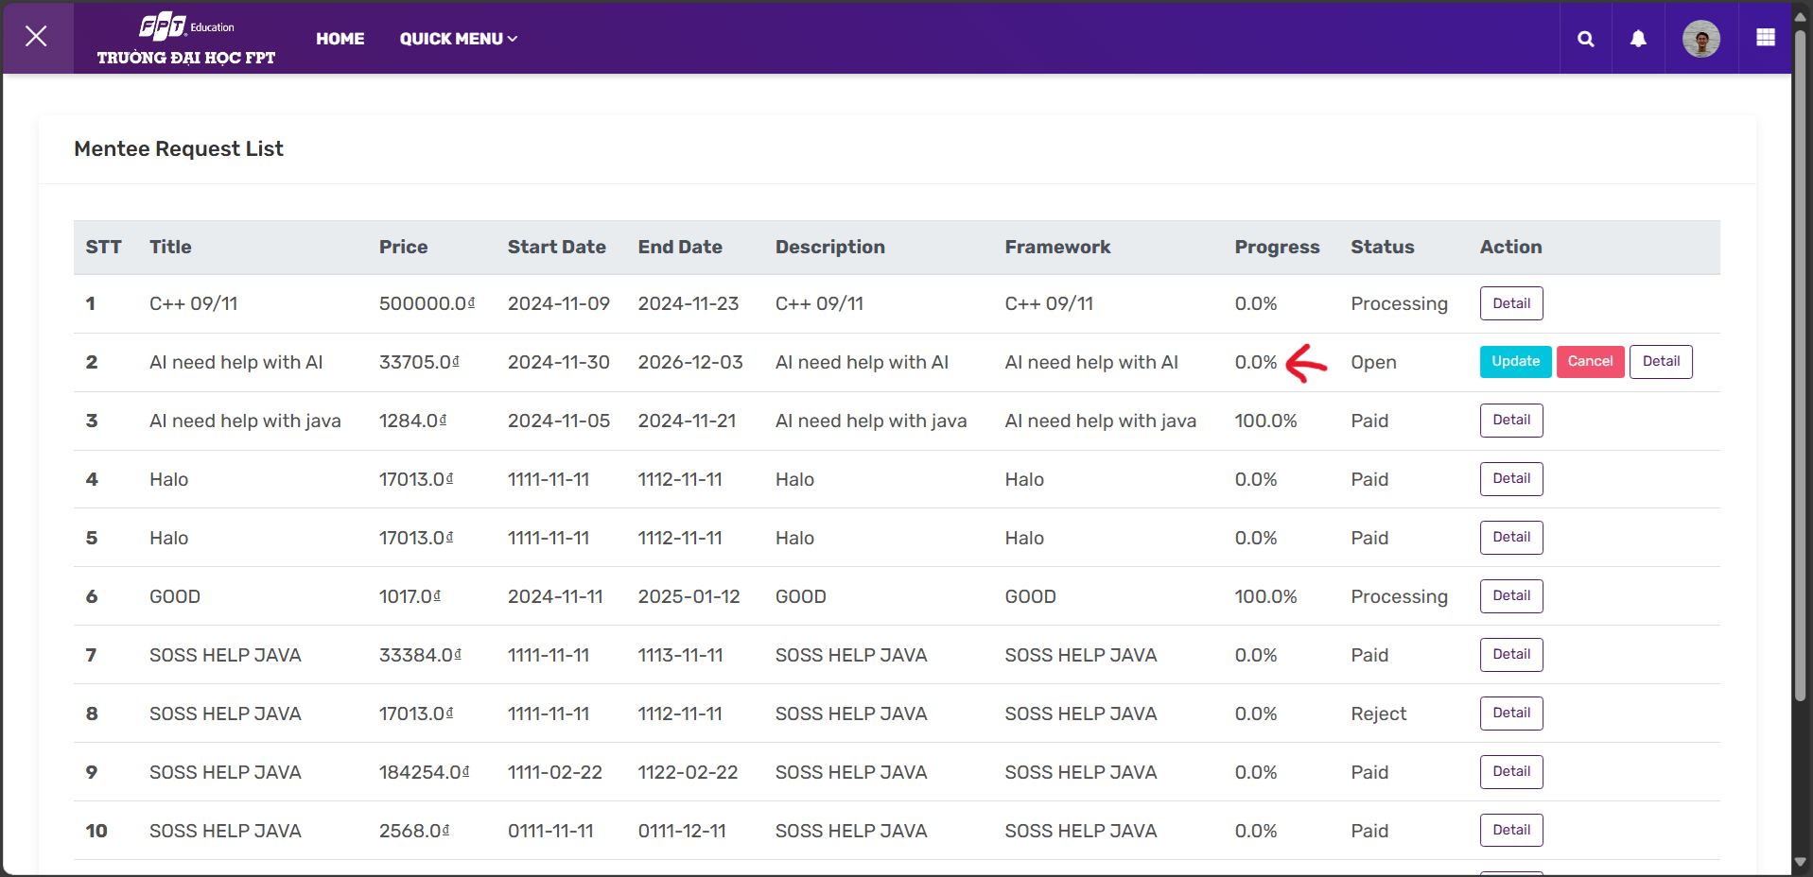

*2. Skill Mentee can watch their whole schedule  
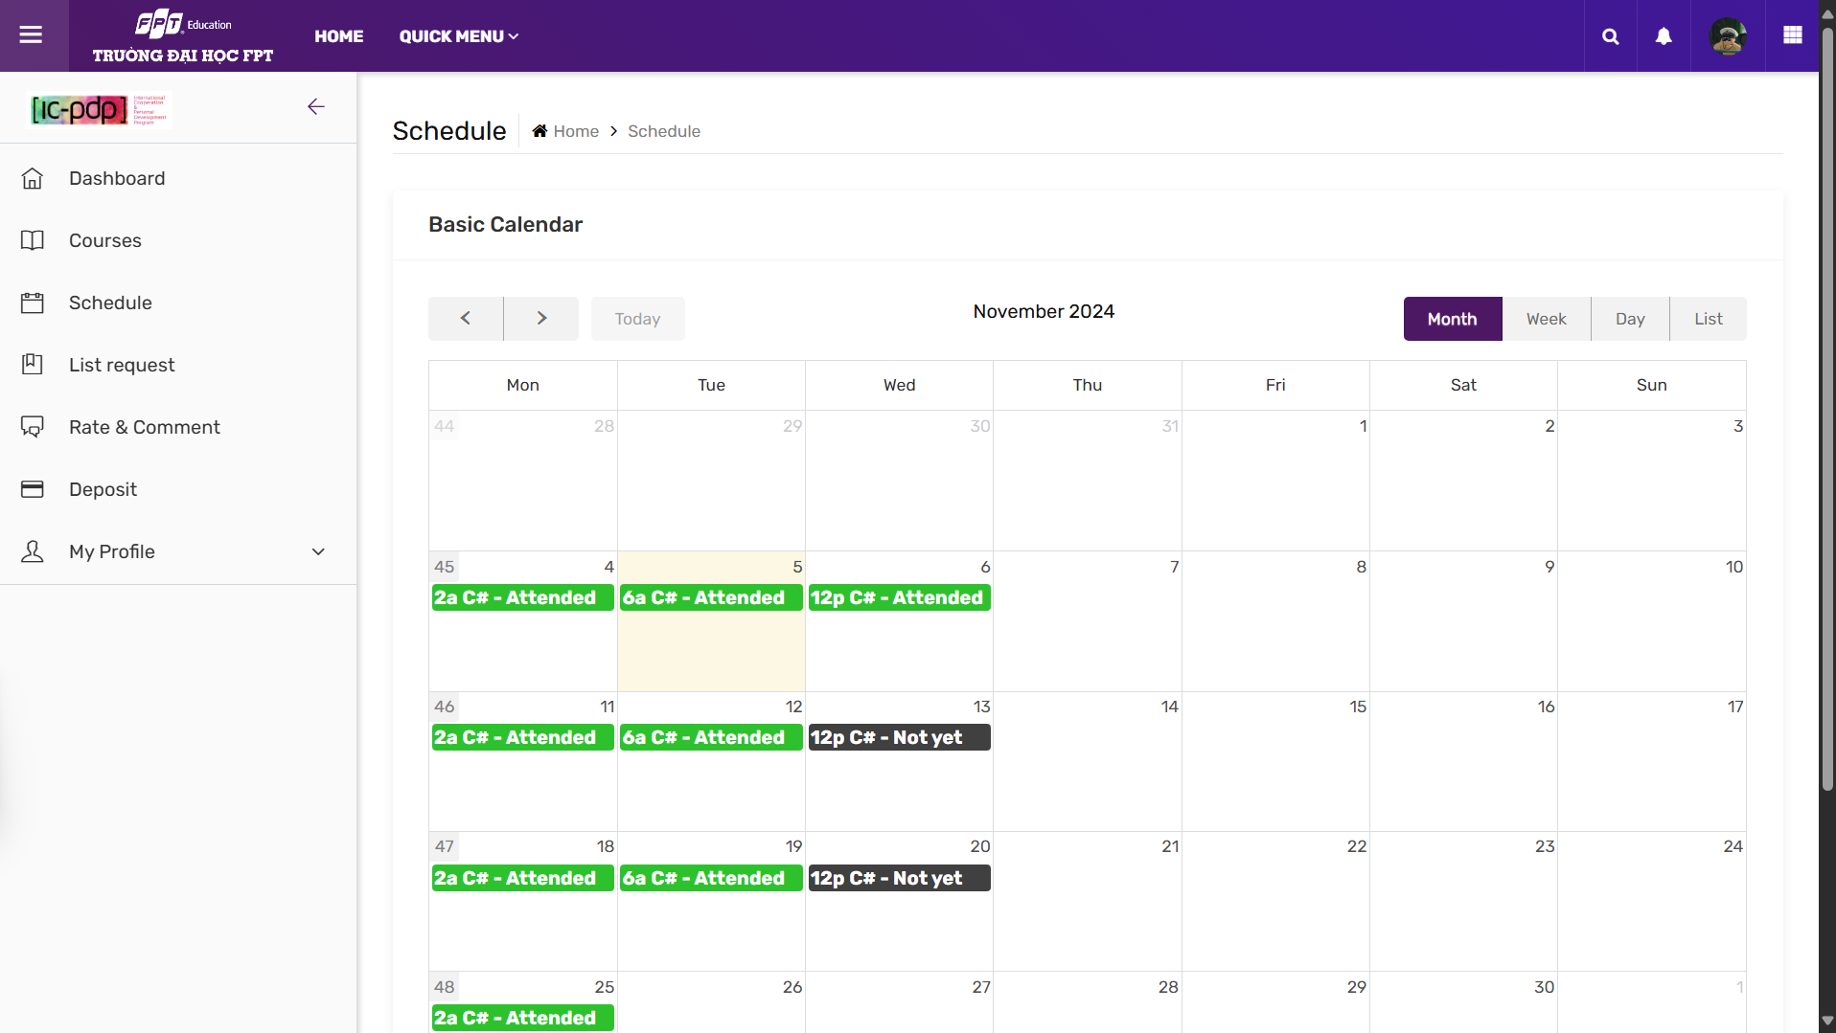*

*3. View request from Mentee, update, cancel, complete and view course detail*

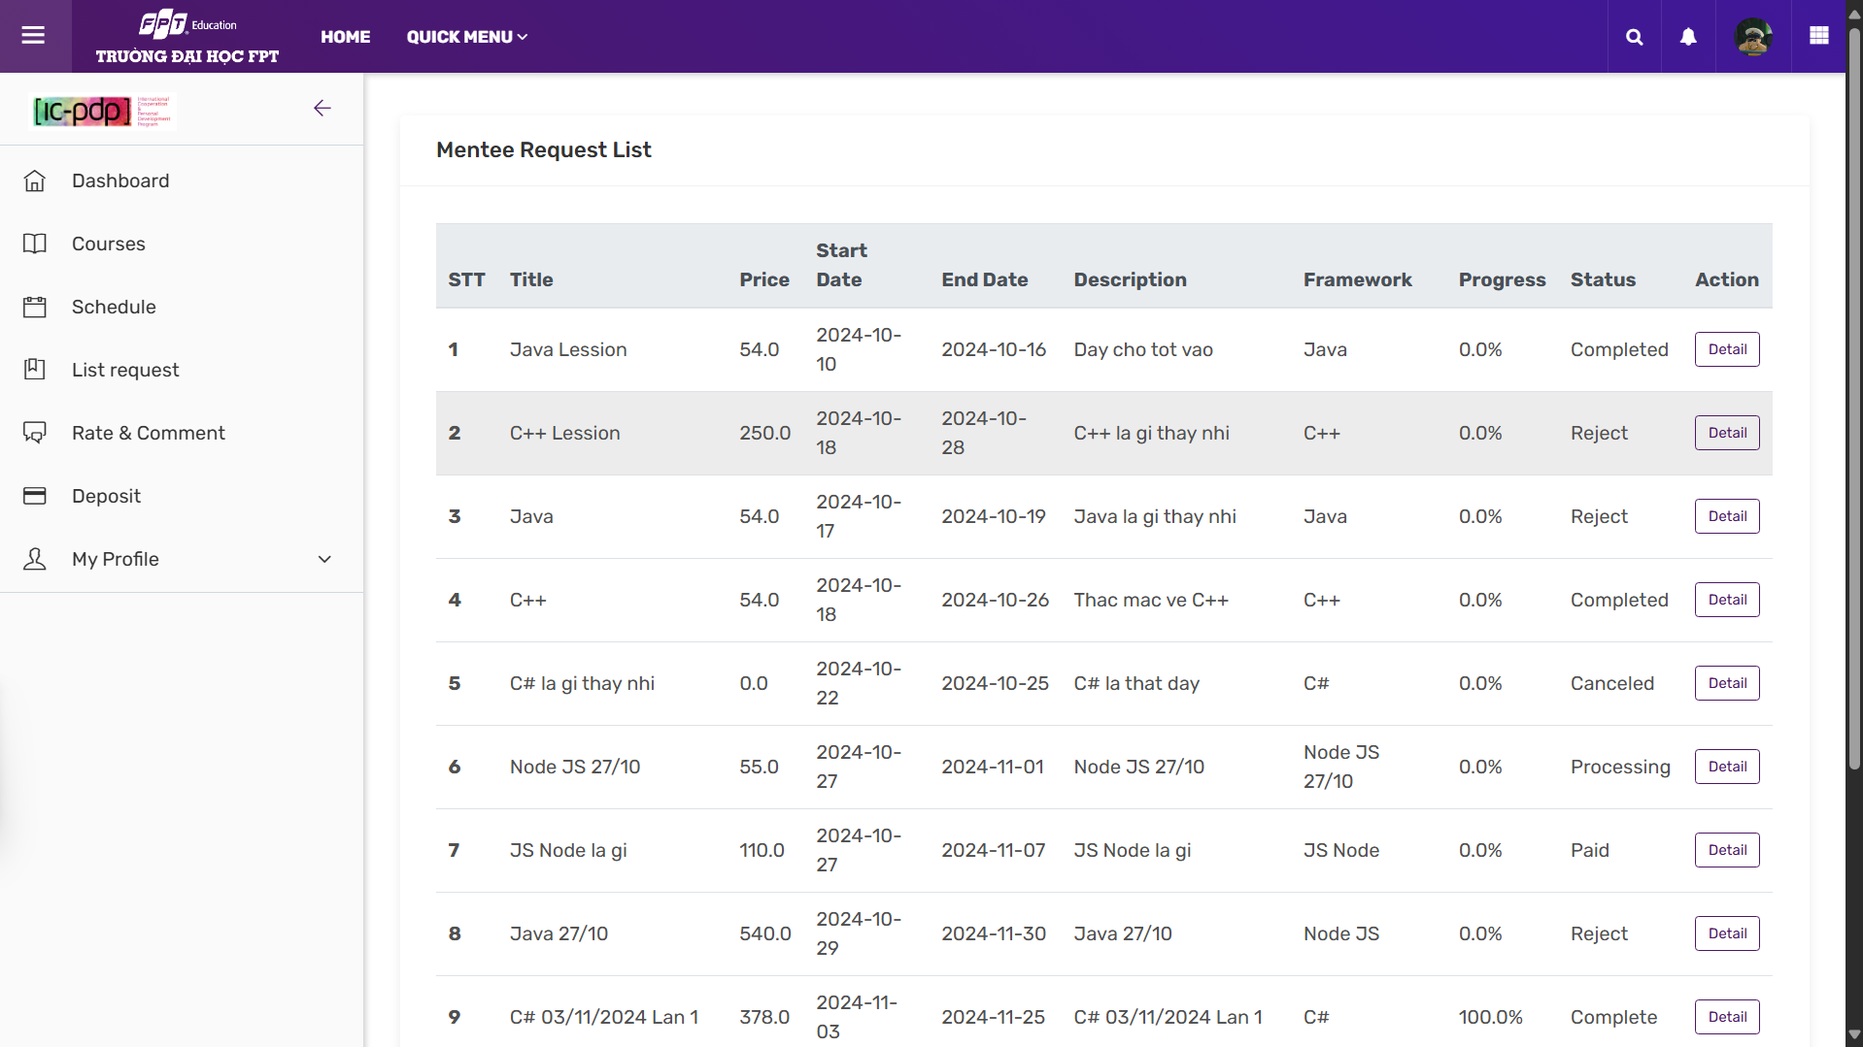

*4. Mentee can rate & comment Mentor whom they have already learned*

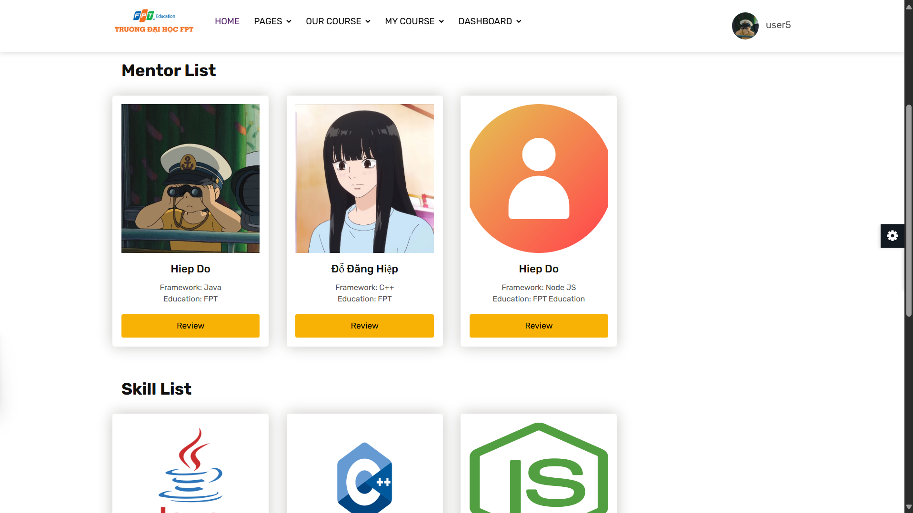

*5. Mentee can charge and watch overall transaction*

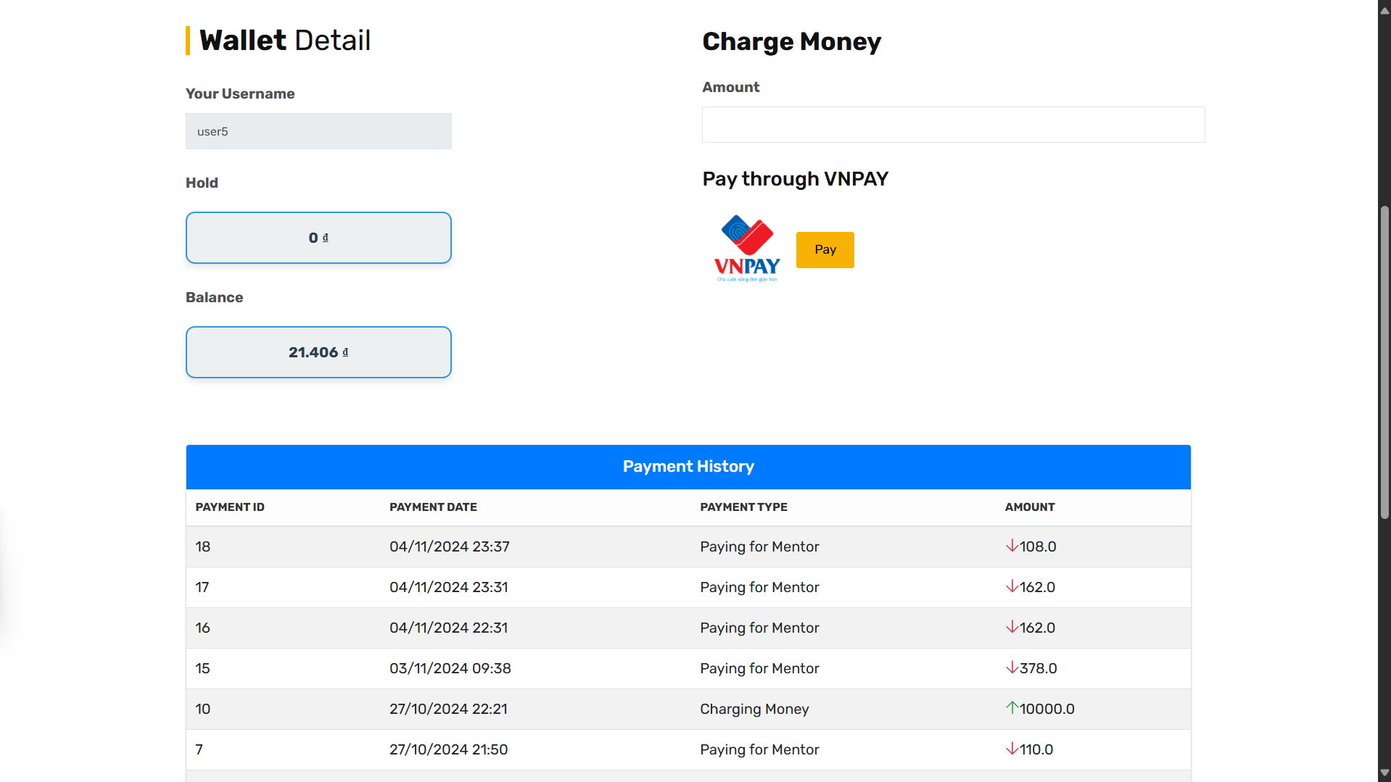

*6. Mentee can adjust their information  
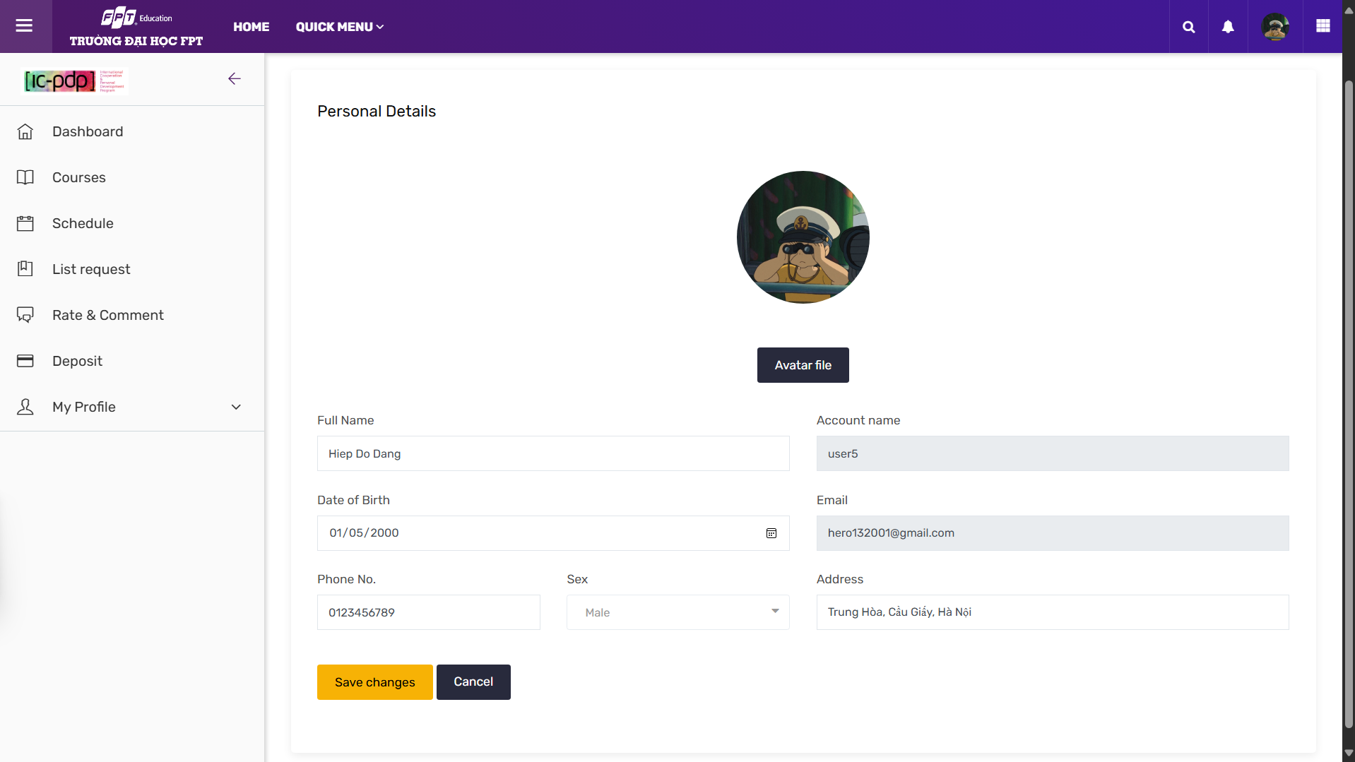*

*7. Mentee can change password when logging*

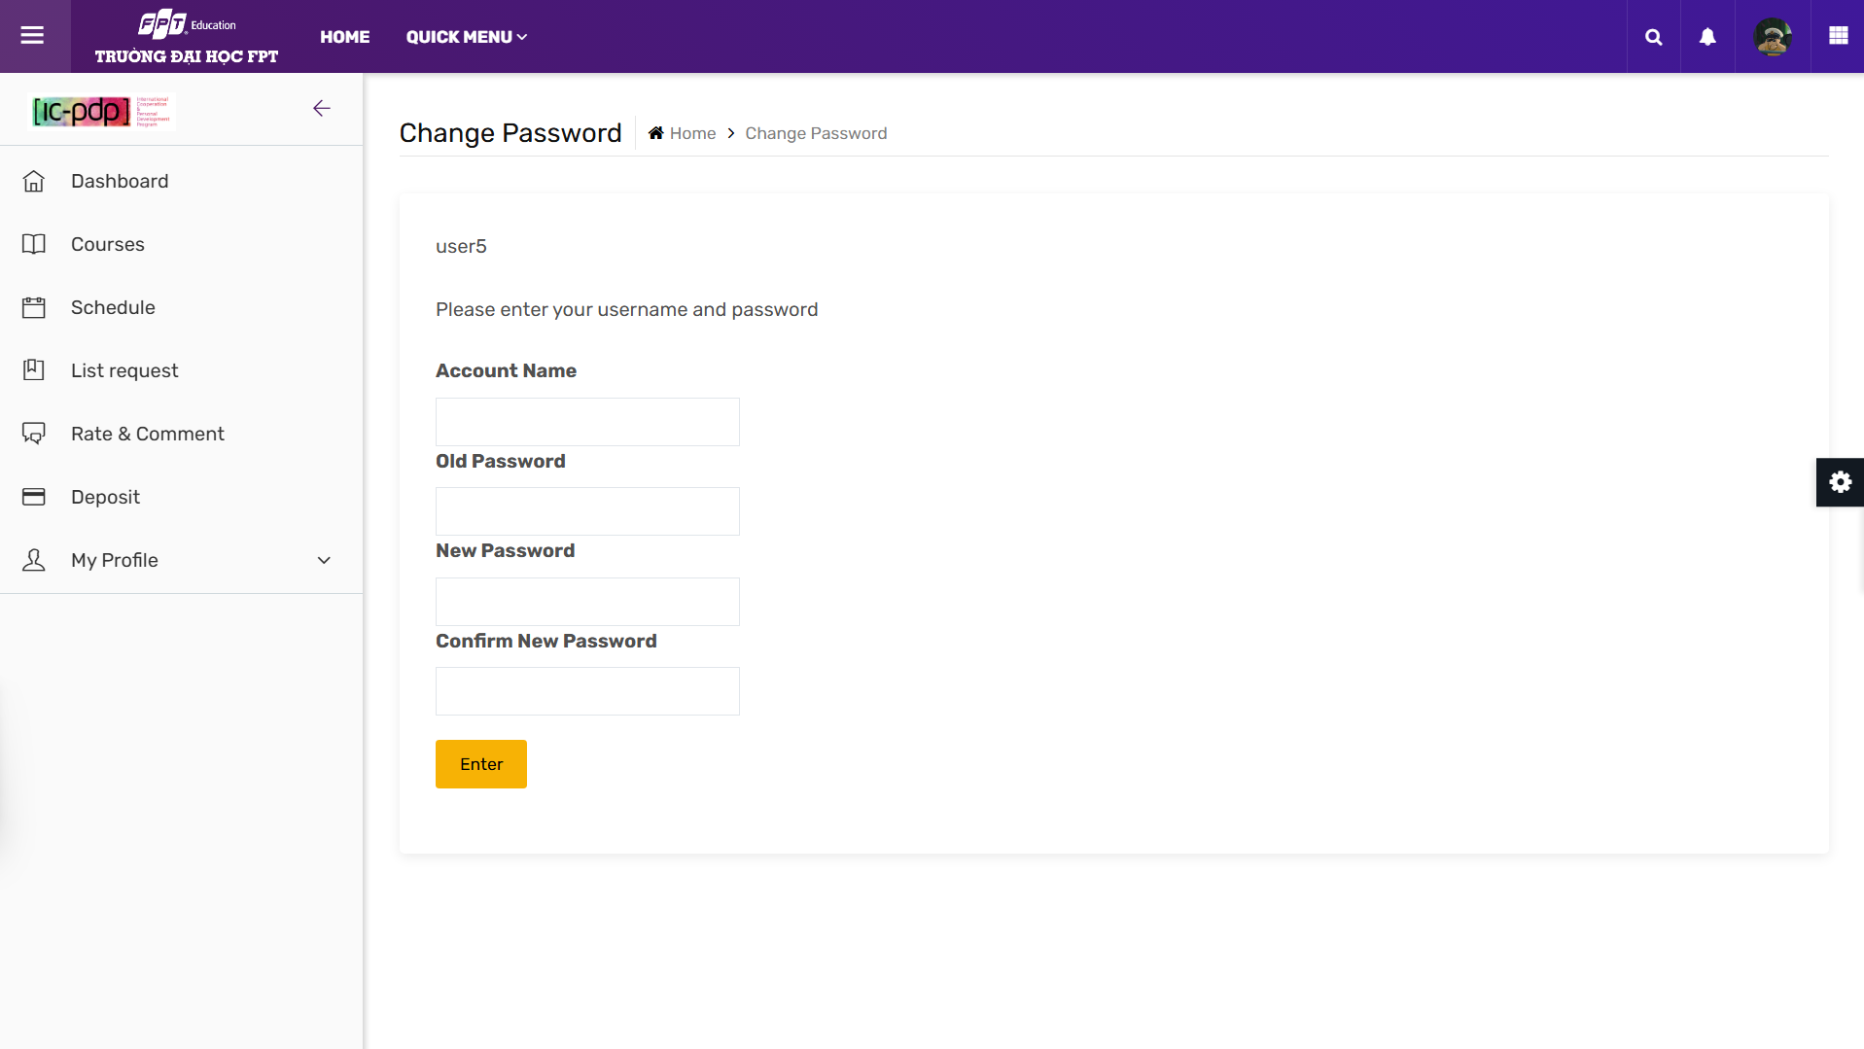

## 6.Mentor Inviting Request

### Inviting Request Management

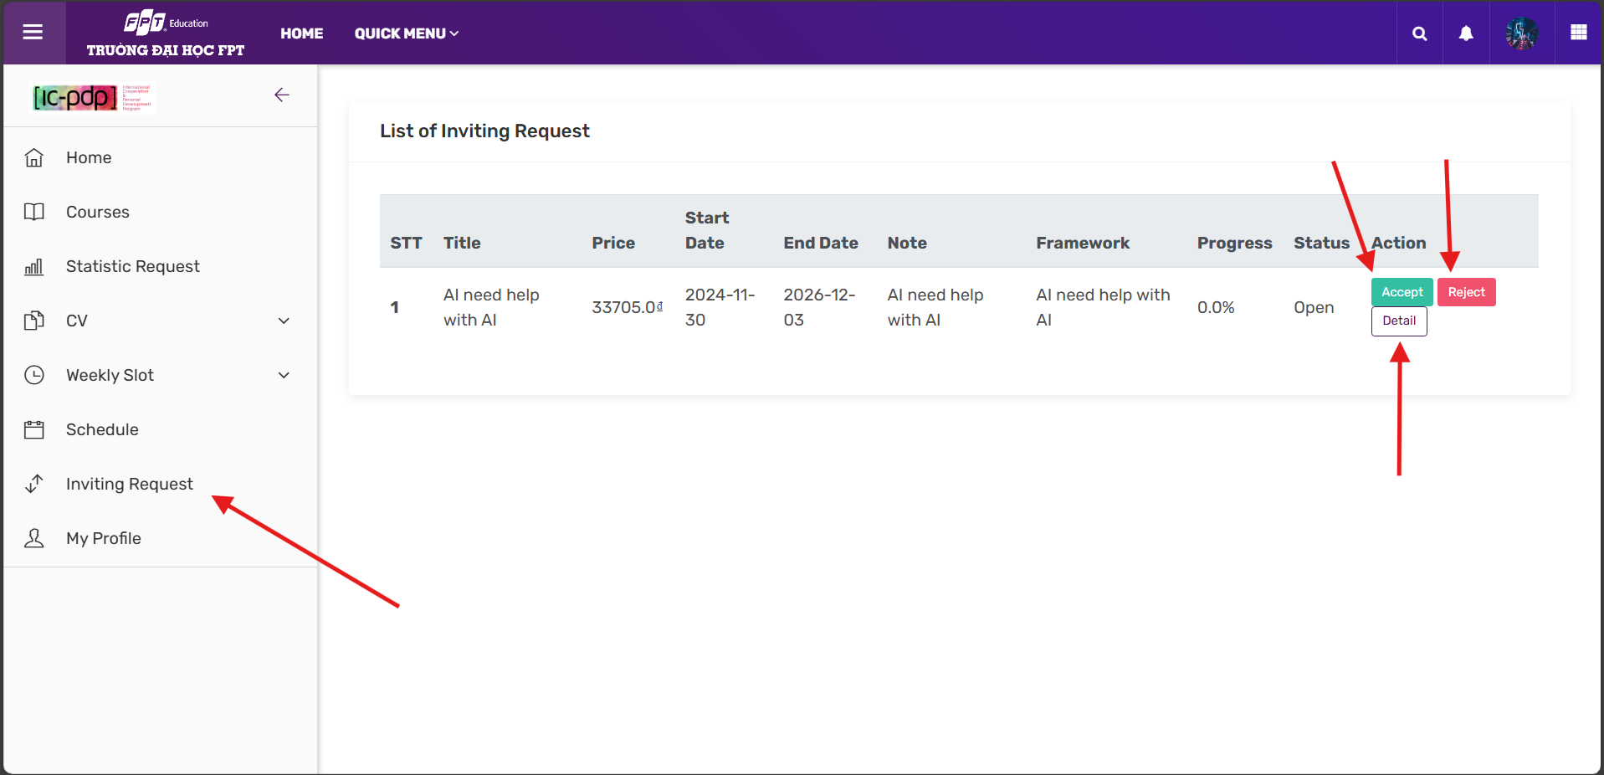

#### Step 1: Move to the left menu then pressing Inviting Request, after that choose 1 from 2 options. If accepting a request, Manager has to approve before Mentor is able to participating in the course.

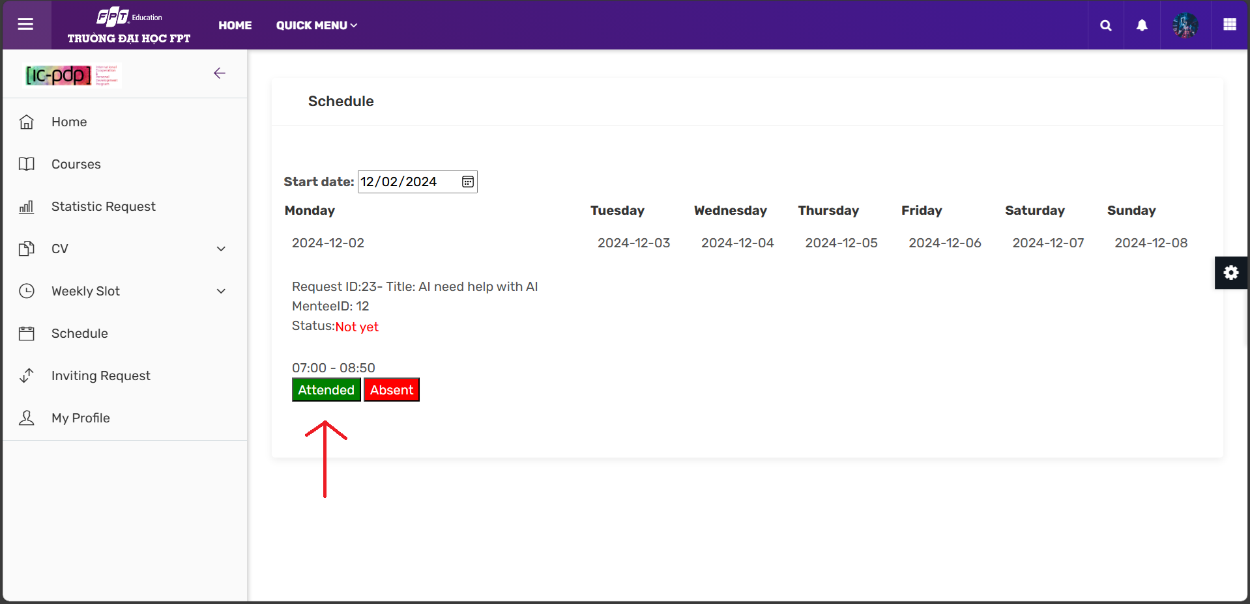

#### Step 2: Mentor needs to present every Mentee slot for reaching 100% of progress.

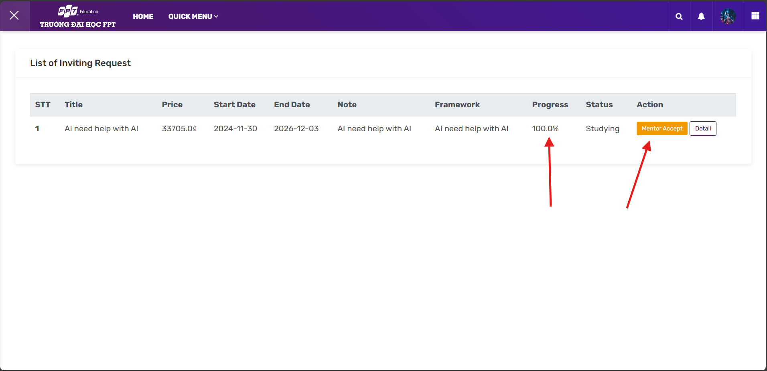

#### Step 3: After reaching 100% of progress, it will pop up Mentor Accept button to confirm the ending course.

### View CV Profile

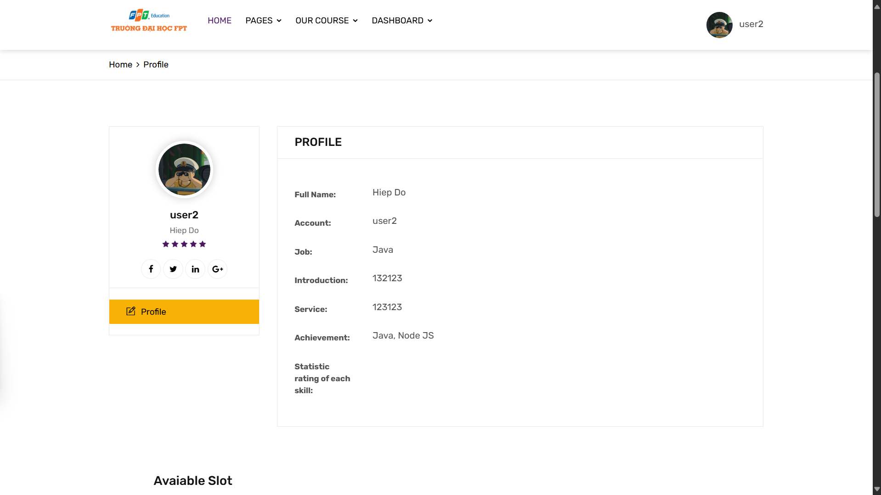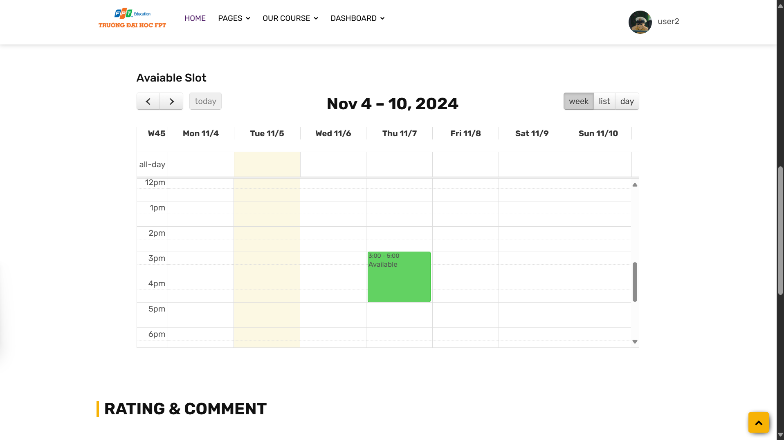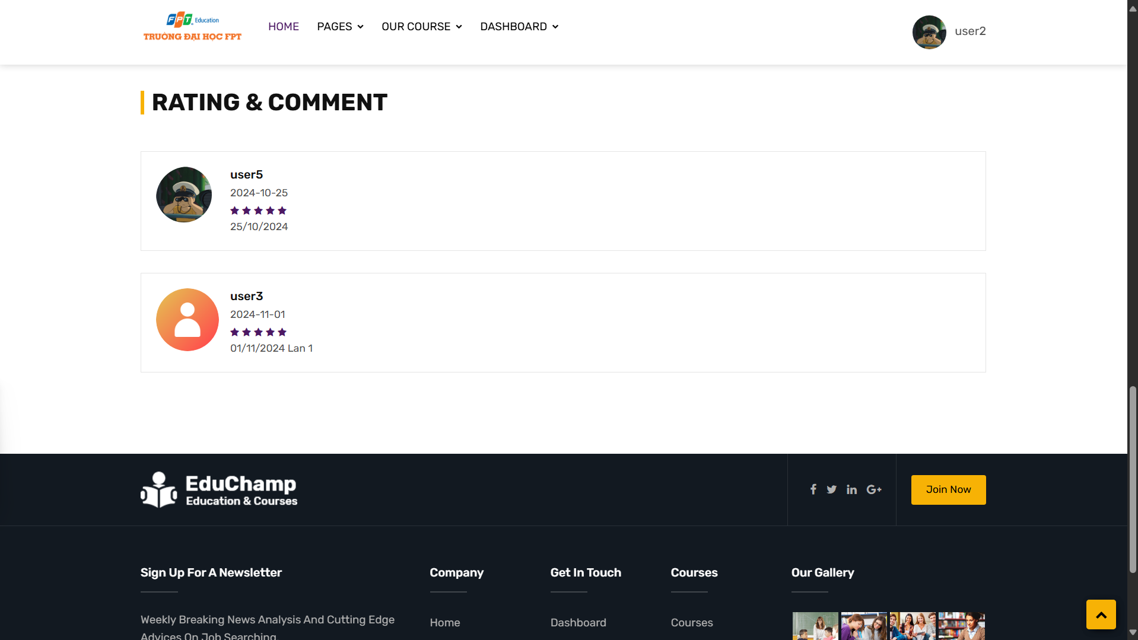

*1. Watch Mentor profile (include: Mentor information, schedule, rating and comment)*

## 7.Manager

### Manager CV & Slot of Mentor



#### Step 1: Enter link http://localhost:9999/happy_programming/loginAdmin and login as Manager (default manager;123)

#### Step 2: Manager can click 2 small icon in Mentor List to view CV or Slot, Manager can click (X) or (V) button next to status to change status.

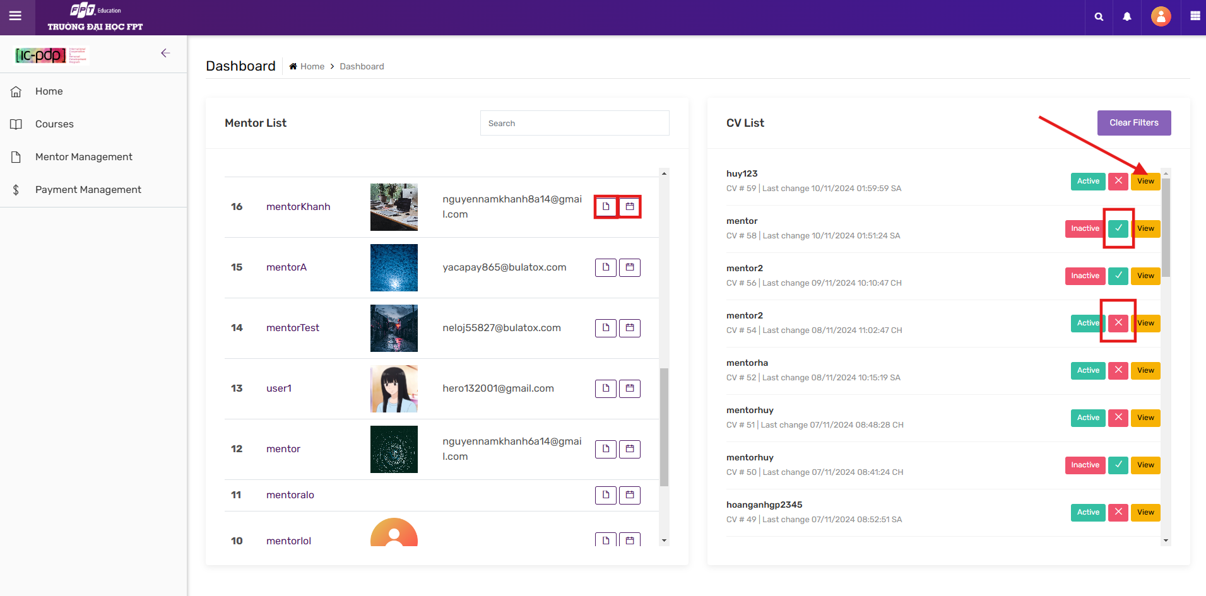

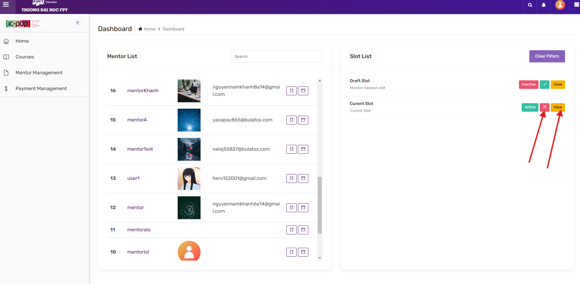

#### 

#### Step 3: After click view button, it will popup a detailed CV or Slot of that mentor

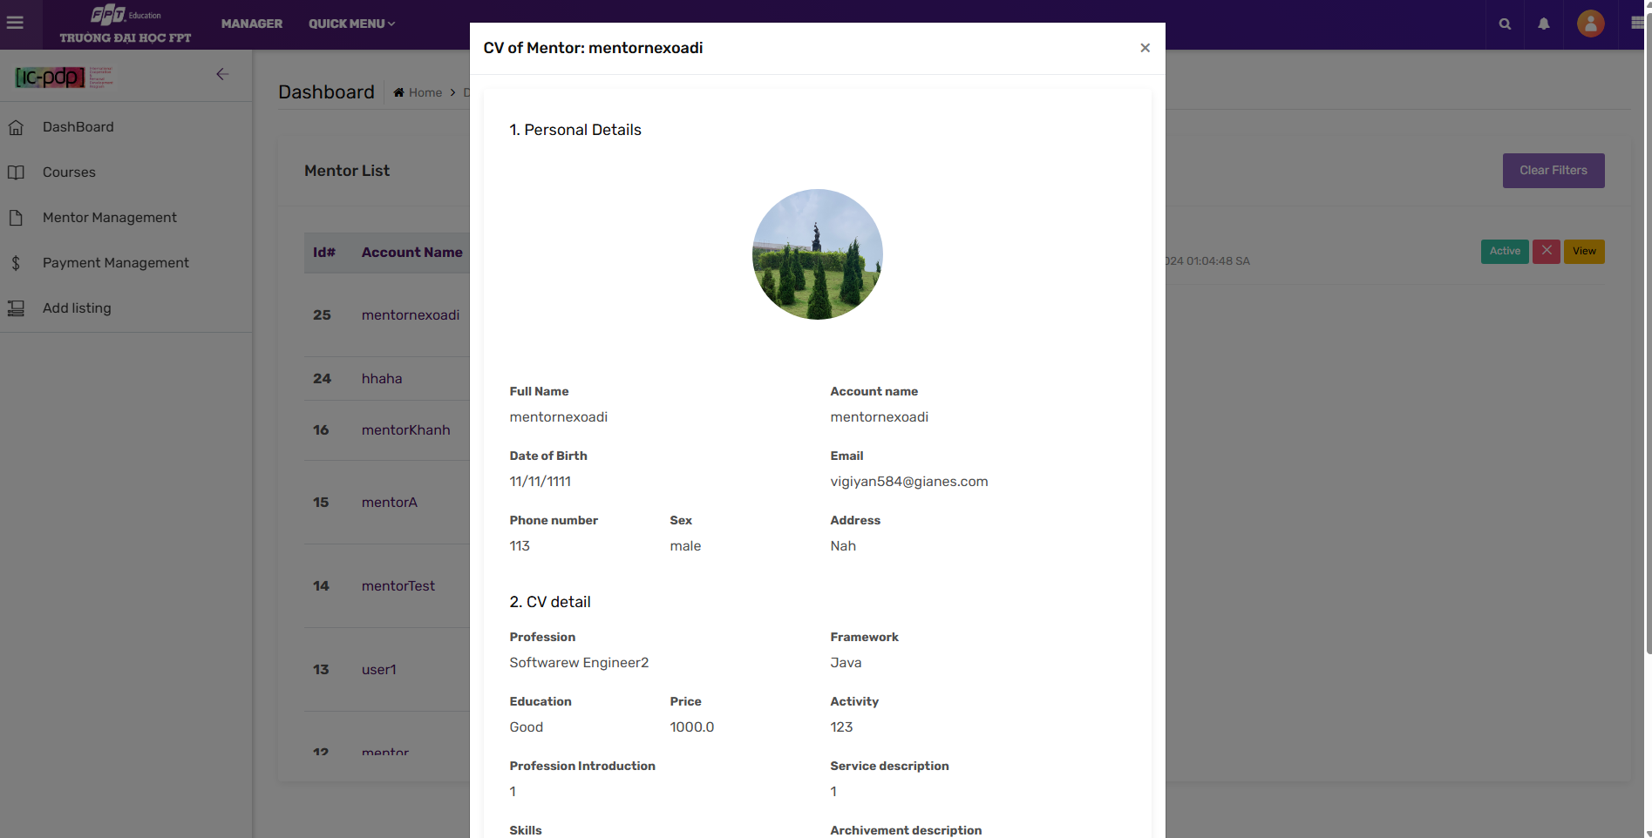

## 

### Manager Payment

#### Step 1: Click Payment Management in navbar, click detail to see request payment detail.

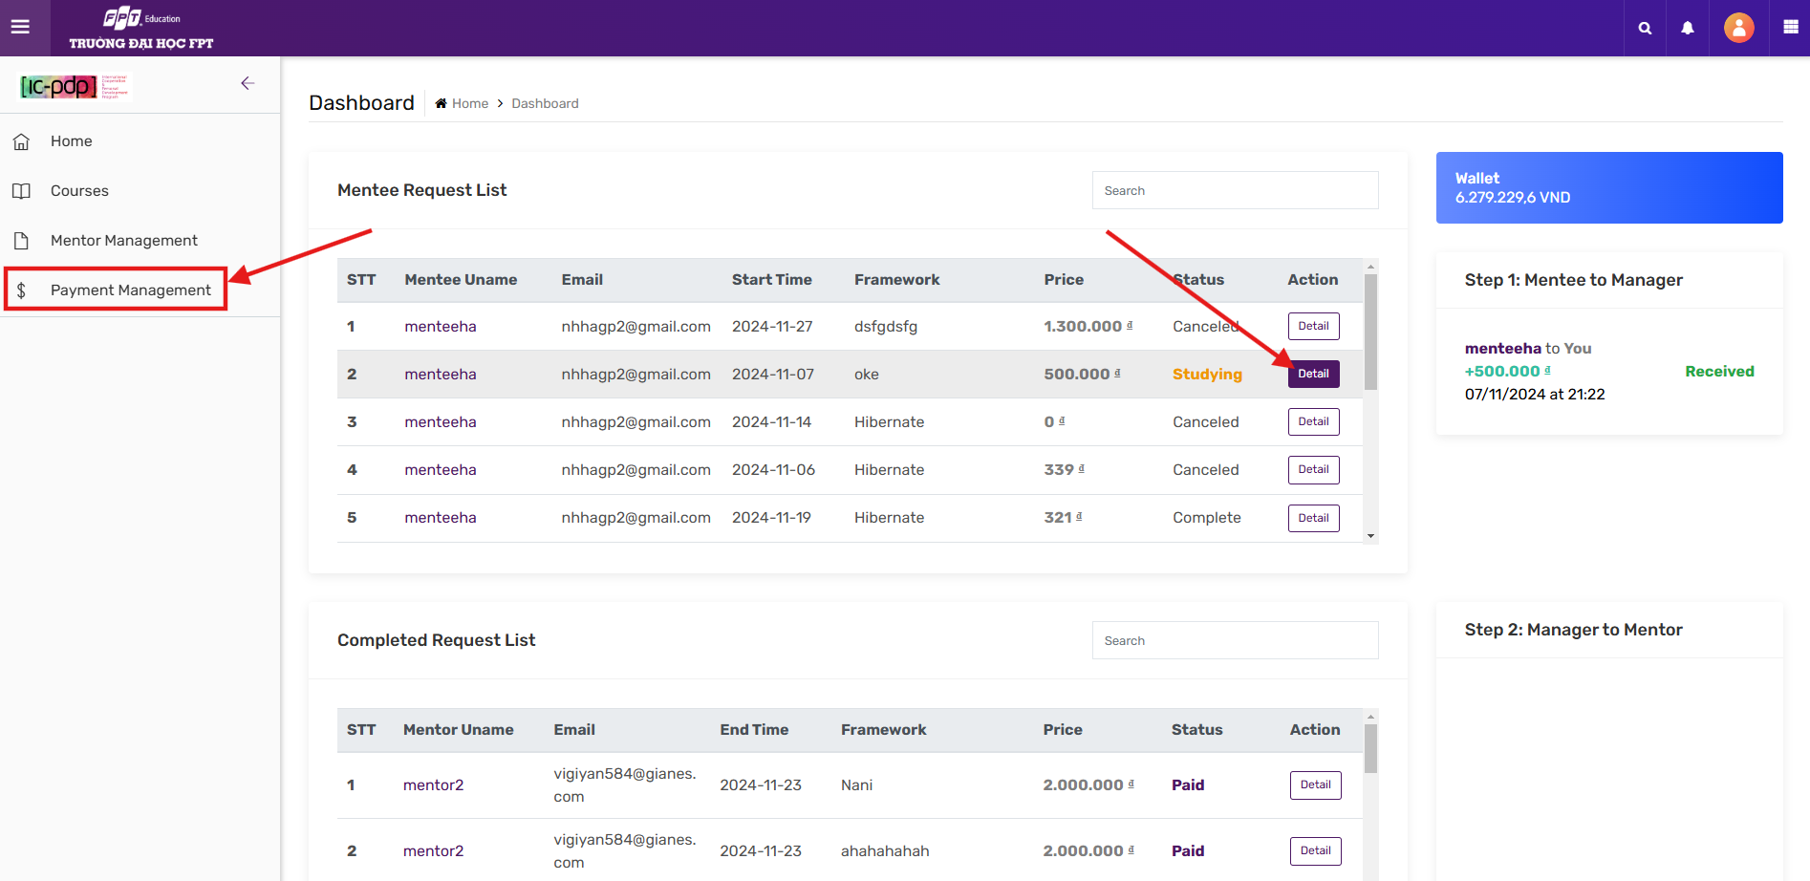

#### Step 2: When mentor accept request from mentee, new request will display on top

## 

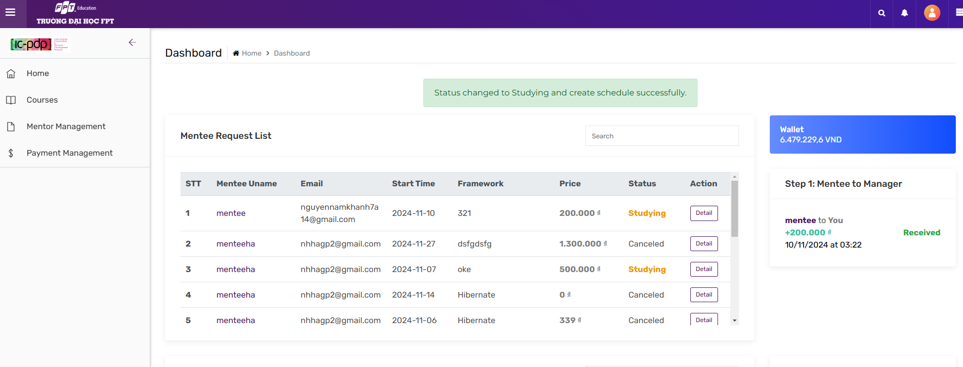

#### Step 3: After mentor and mentee confirm complete request, you can click confirm payment to pay mentor

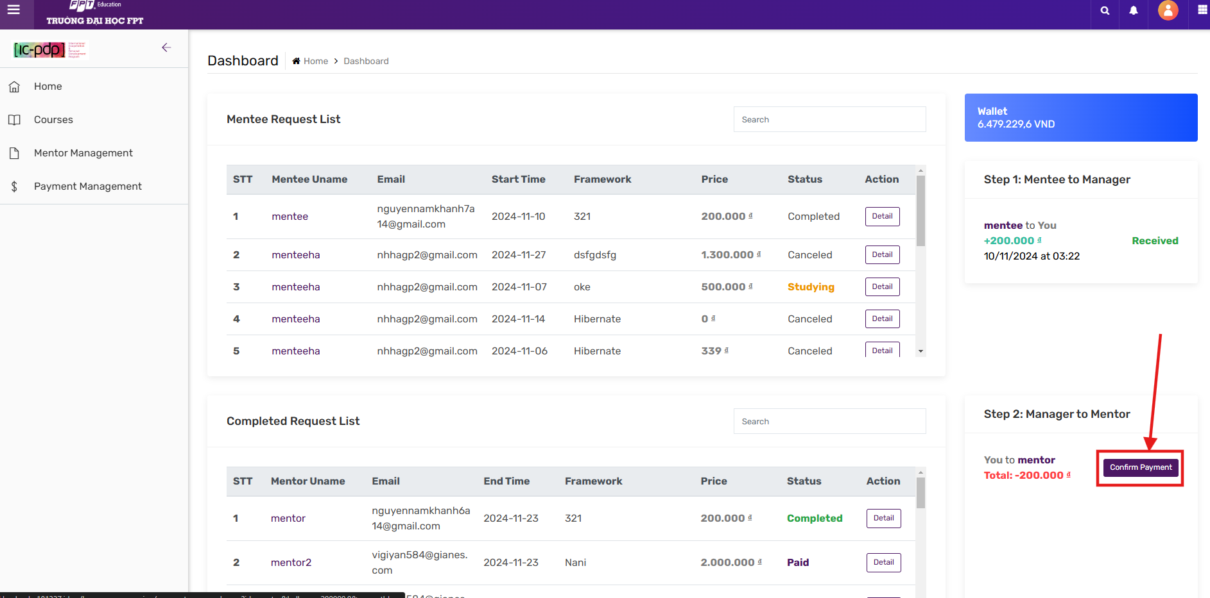

#### Step 4: After you pay mentor, you will receive commission 20% of request

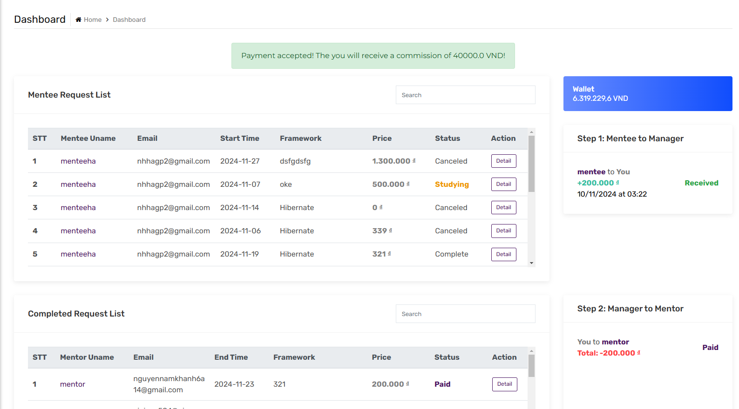

## 8.Admin

### a . Admin manage Skill-Admin logs in with an account that has been granted admin rights

-In the left menu bar of the screen, expand Skill Management and select Skill

-Go to the screen with a list of all Skills and information about each Skill

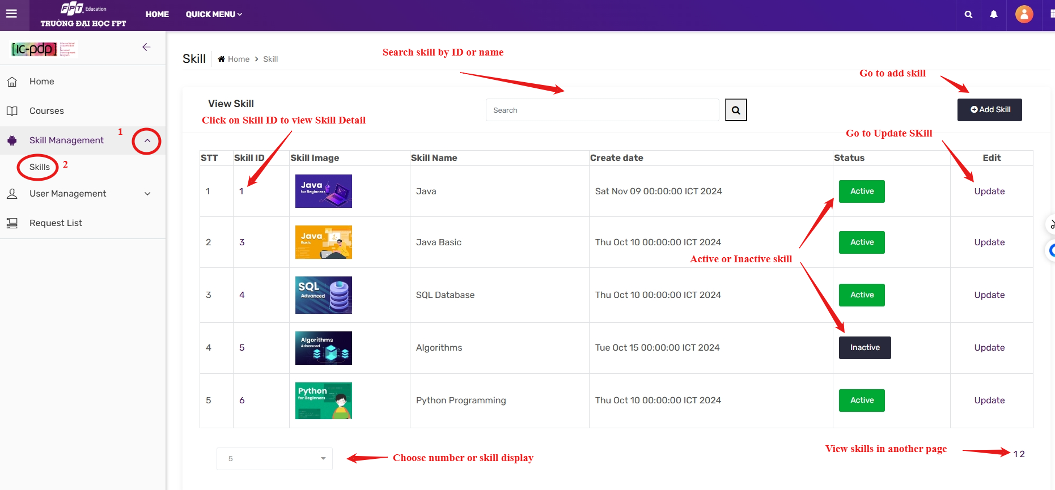

-Checkout the Skill detail Page:  
+View Skill Detail  
+View all request of that skill  
+View all mentor put that skill on cv  
+Update Skill status on button  
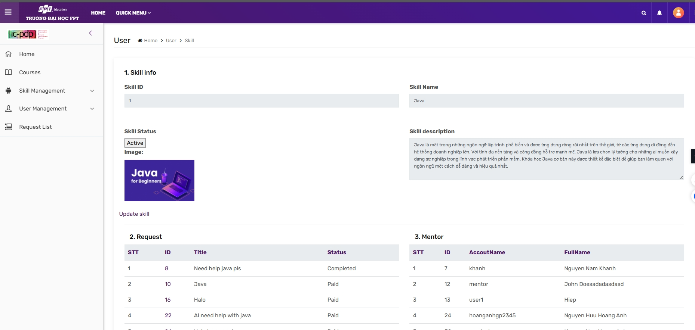

-When you want to add a new skill to the system

+Click the add skill button in the upper right corner of the screen

+The screen displays the form to enter new skill information

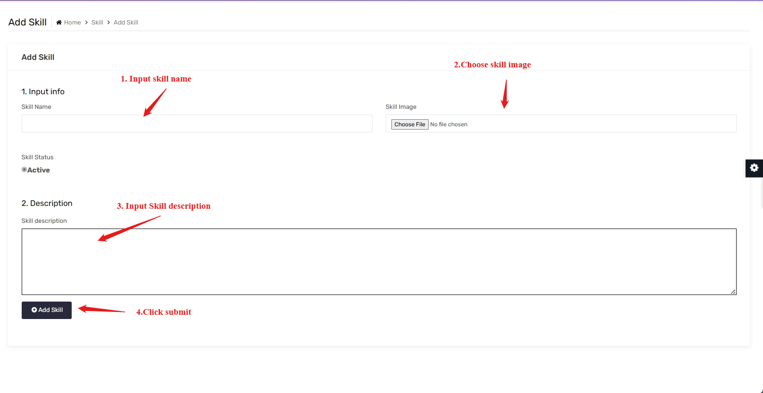

*Note: The system will confirm the validity of the new skill, please pay attention to the system's warnings.

-When you want to change skill information

+ Click update on the skill you want to change information

+The screen displays current skill information

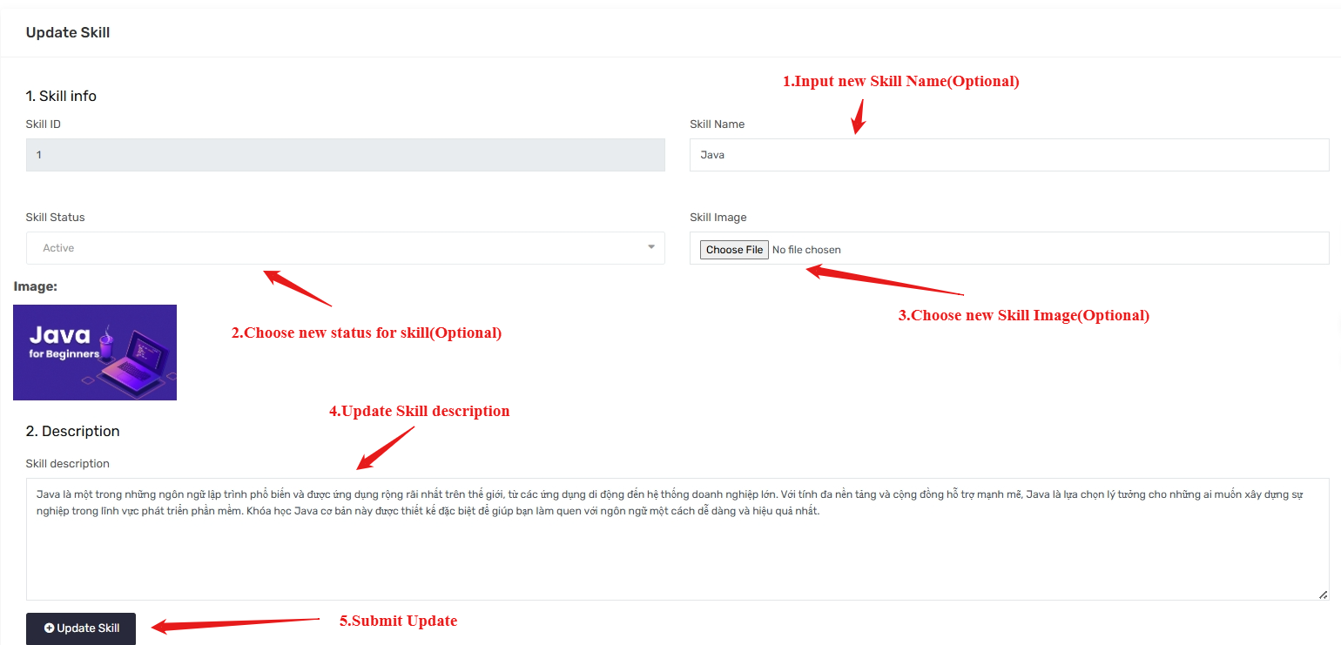  
Note: The system will confirm whether the new skill information is valid for updating or not, please pay attention to the system's warnings.

### b. Admin manage User

#### 1.Admin manage Mentor

* Admin logs in with an account that has been granted admin rights
* In the left menu bar of the screen, expand User and select Mentor List
* The screen displays a list of mentors

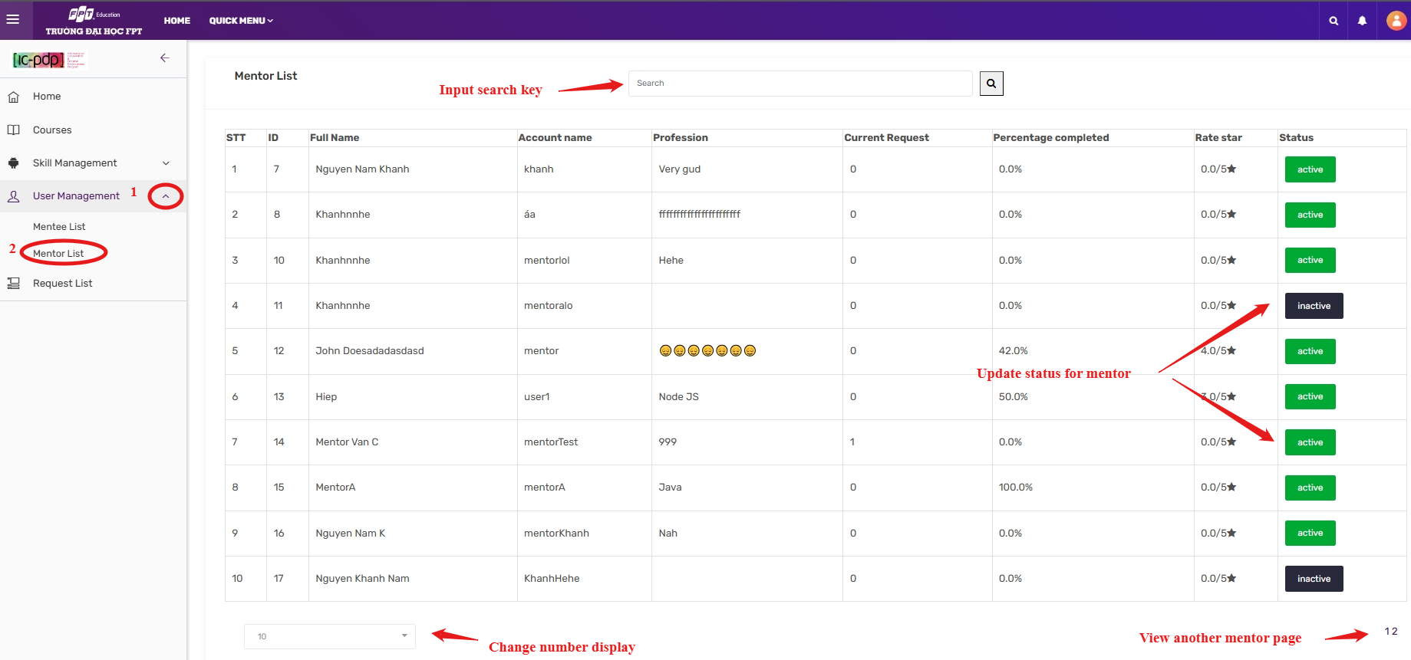

When Active a mentor:

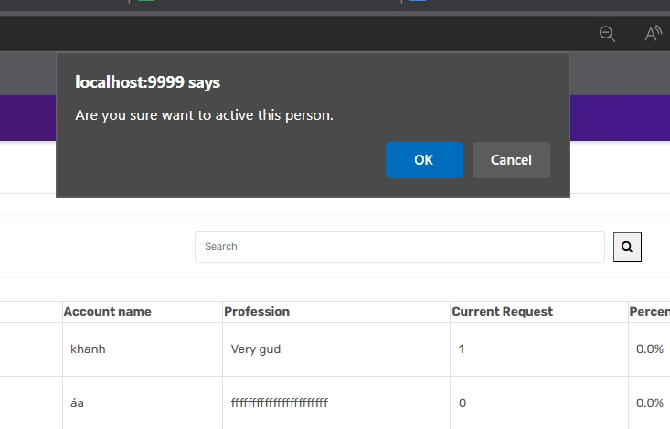   
You cannot active mentor lack of Active slot or Active CV:  
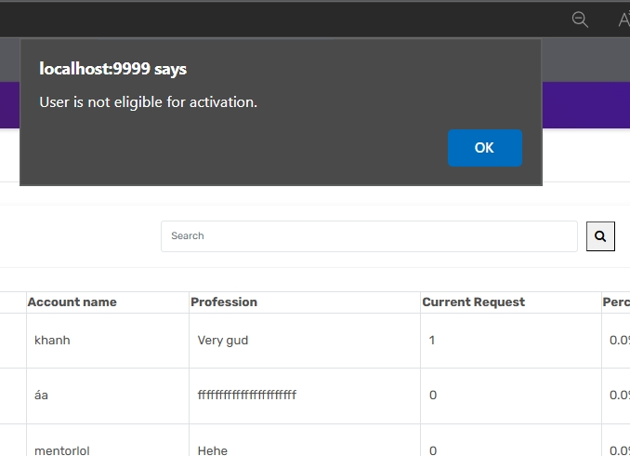

#### 2. Admin manage mentee list

* Admin logs in with an account that has been granted admin rights
* In the left menu bar of the screen, expand User and select Mentee List
* The screen displays a list of mentees

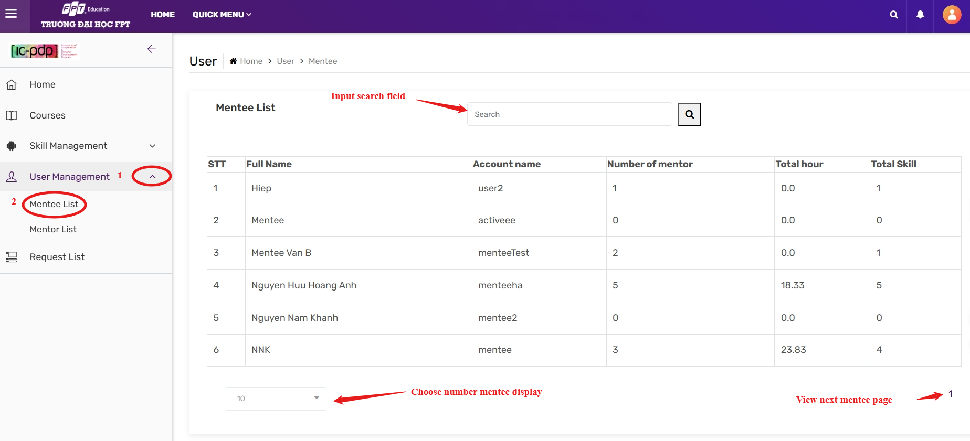

### c. Admin manage request

* Admin logs in with an account that has been granted admin rights
* On left menu bar choose request list
* The screen displays a list of Requests

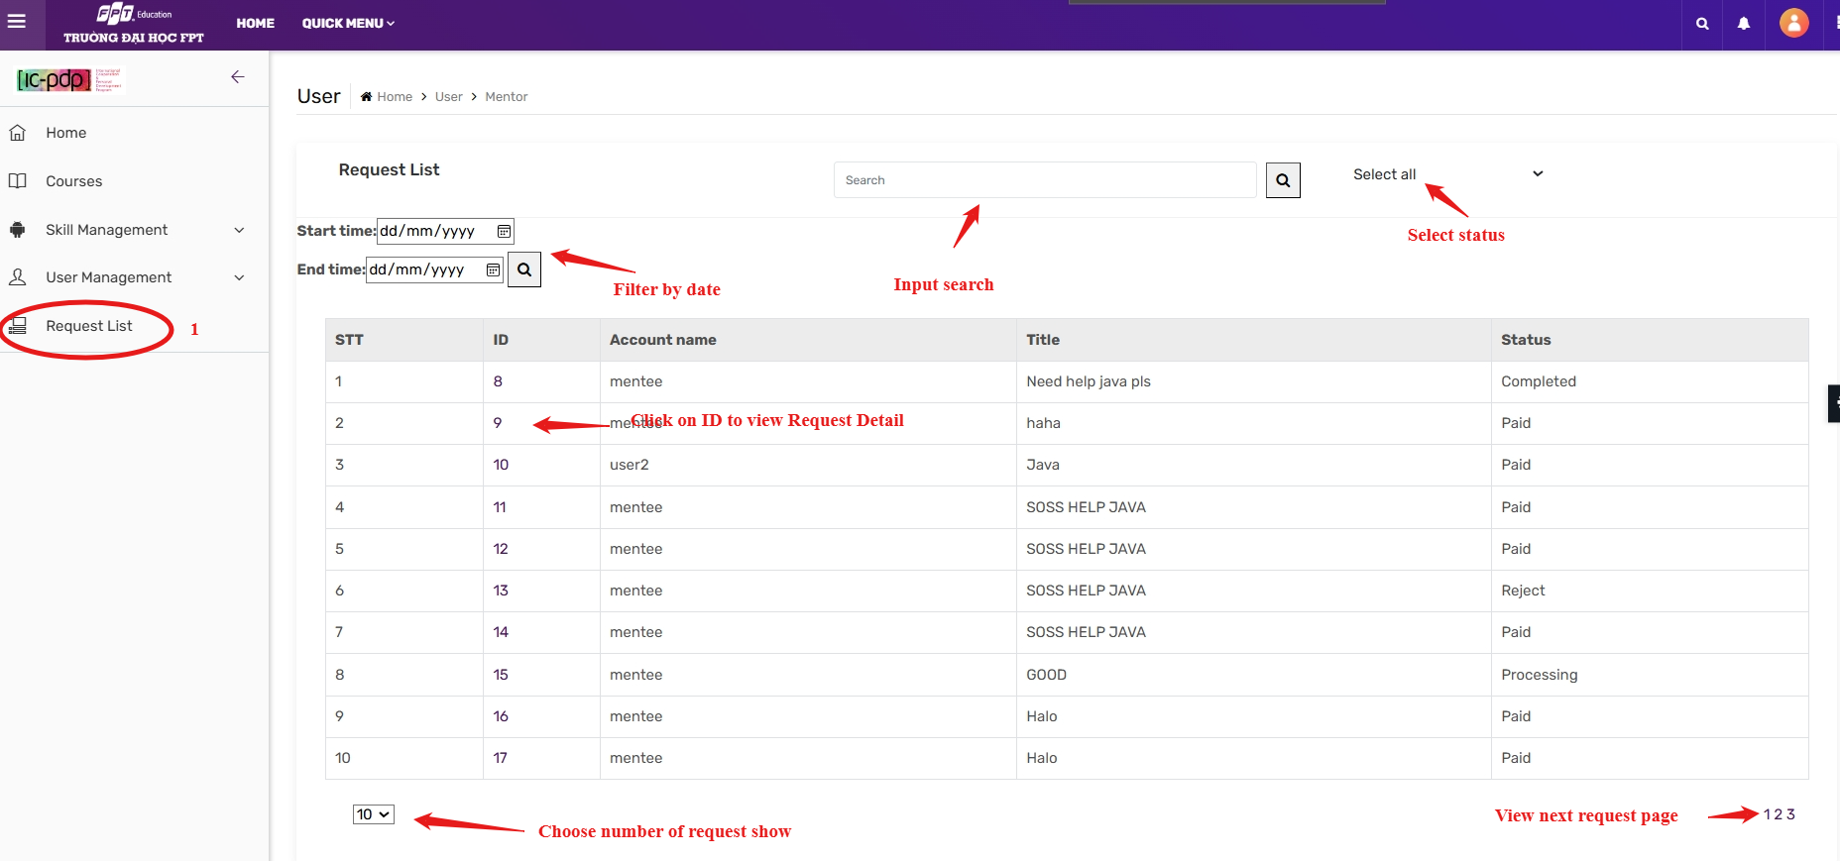

-Request Detail page:  


 